**Multi-Label Fault Classification in a Rotor System using Deep Convolution Networks**

A Thesis Submitted

In Partial Fulfillment of the Requirements

For the Degree of

Master of Science (Research)

by

Dhage Gaurav Sahebrao

(18105407)



**Department of Mechanical Engineering**

Indian Institute of Technology

Kanpur-208016 (India)

**Declaration**

This is to certify that the thesis titled “Multi-Label Fault Classification in a Rotor System using Deep Convolution Networks” has been authored by me. It presents the research conducted by me under the supervision of Dr. N. L. Vyas.

To the best of my knowledge, it is an original work, both in terms of research content and narrative, and has not been submitted elsewhere, in part or in full, for a degree. Further, due credit has been attributed to the relevant state-of-the-art and collaborations (if any) with appropriate citations and acknowledgements, in line with established norms and practices.



Dhage Gaurav Sahebrao

Programme: MS (by research)

Department of Mechanical Engineering

Indian Institute of Technology Kanpur

Kanpur 208016



ABSTRACT

The present study aims at developing a deep neural network-based Multi-label fault classifier for condition monitoring of the rotor system. Multilabel classification is a generalised version of a Multiclass classification problem in which one data point may belong to more than one target class. If there are *n* numbers of independent target classes, then the total numbers of possible combinations for any data point are $2^{n}$.As the number of classes increases, there is an exponential rise in the total number of combinations. Therefore it is nearly impossible to collect data for all combinations and train network considering each combination as an individual class. The objective is to use deep learning protocol for Multi-label classificationof faults in the rotor system and to develop a generalisedmachine learning model for classification of both distinct and combined defects. The methodology is as follows; vibration response data corresponding to distinct faults collected by six sensors is used for training convolutional neural network, and testing is done on the data of both combined and distinct faults. For each distinct fault, one model is trained to predict whether that fault is present or not in the system. As a result, 2 out of 7 combined faults are classified with an accuracy of 100%, while other combined faults are partially classified.

Dedicated to my mother

Mrs. Padma Sahebrao Dhage

## ACKNOWLEDGEMENT

I would first like to thank my thesis advisor Dr. Nalinaksh S. Vyas for guiding and supporting me in the right direction. I would also like to thank Major Jasdeep Singh, whose experimental data was very useful in the present study and Nikhil Sonkul who guided me throughout my journey. Without their work the thesis objective could not have been achieved.

I must express my gratitude to my parents and to my sisters for providing me unconditional support and continuous encouragement throughout my years of study. This work would not have been possible without them.

I thank to all my lab mates, O.P. Yadav, Ravi Kumar, Ajay, Tarun, Chetan and Rushabh for their fruitful discussions throughout my institute tenure. I appreciate and extend my thanks to Mohsin Sir, Mr. Rohit, Mr. Ramshankar, Mrs, Shashi for providing lively working environment and making my stay in laboratory comfortable. Thank you.

Dhage Gaurav Sahebrao

CONTENTS

ACKNOWLEDGEMENT v

LIST of FIGURES vii

LIST of TABLES ix

CHAPTER 1 INTRODUCTION 1

CHAPTER 2 LITERATURE REVIEW 4

CHAPTER 3 MACHINE LEARNING & MULTI-LABEL CLASSIFICATION 7

3.1 Artificial Neural Network 7

3.2 Convolutional Neural Network 8

3.3 Convolution Layer 9

3.4 Batch Normlisation Layer 11

3.5 Dropout Layer 12

3.6 Activation Functions 12

3.7 Multi-Label Classification 14

3.8 Remarks 16

CHAPTER 4 ROTOR SYSTEM & DATA 17

4.1 Machine Fault Simulator 17

4.2 Rotor System & Data Acquisition 17

4.3 Types of Faults 18

4.4 Remarks 24

CHAPTER 5 NETWORK ARCHITECTURES, TRAINING & VALIDATION 25

5.1 Network Architectures & Results 39

5.2 Remarks 41

CHAPTER 6 STFT ANALYSIS 42

6.1 STFT Plots 42

6.2 STFT Observations 58

6.3 Analysis 59

CHAPTER 7 CONCLUSION 61

## LIST of FIGURES

**Figure 1: Feed forward neural network with two hidden layers** 8

**Figure 2: Convolutional layer with stride 2 (left) v/s fully connected layer (right)** 10

**Figure 3: Logistic Sigmoidal Function** 13

**Figure 4: Hyperbolic Linear Tangent Function** 13

**Figure 5: ReLU Function** 13

**Figure 6: A Typical Response from Sensors for a Particular Faul** 22

**Figure 7: Network Architecture (A)** 34

**Figure 8: Network Architecture (B)** 34

**Figure 9: Network Architecture (C)** 35

**Figure 10: Network Architecture (D)** 35

**Figure 11: Network Architecture (E)** 36

**Figure 12: Network Architecture (F)** 36

**Figure 13: Network Architecture (G)** 37

**Figure 14: Network Architecture (H)** 37

**Figure 15: Network Architecture (I)** 38

**Figure 16: Network Architecture (J)** 38

**Figure 17: Network Architecture (K)** 39

**Figure 18: STFT plot of 'Missing Tooth Fault’, 3D (upper part), 2D (lower part)** 43

**Figure 19: STFT plot of 'Loose Gear Fault’, 3D (upper part), 2D (lower part)** 44

**Figure 20: STFT plot of 'Combined Loose Gear Fault’, 3D (upper part), 2D (lower part)** 45

**Figure 21 STFT plot of 'Unbalance Fault’, 3D (upper part), 2D (lower part)** 46

**Figure 22: STFT plot of 'Combined Unbalance Fault’, 3D (upper part), 2D (lower part)** 47

**Figure 23: STFT plot of 'Eccentric Rotor Fault’, 3D (upper part), 2D (lower part)** 48

**Figure 24: STFT plot of 'Combined Eccentric Rotor Fault’, 3D (upper), 2D (lower part)** 49

**Figure 25: STFT plot of 'Cocked Rotor Fault’, 3D (upper part), 2D (lower part)** 50

**Figure 26: STFT plot of 'Combined Cocked Rotor Fault’, 3D (upper), 2D (lower)** 51

**Figure 27: STFT plot of 'BIRF', 3D (upper part), 2D (lower part)** 52

**Figure 28: STFT plot of 'Combined BIRF’, 3D (upper part), 2D (lower part)** 53

**Figure 29: STFT plot of 'BORF’, 3D (upper part), 2D (lower part)** 54

**Figure 30: STFT plot of 'Combined BORF’, 3D (upper part), 2D (lower part)** 55

**Figure 31: STFT plot of 'BSF’, 3D (upper part), 2D (lower part)** 56

**Figure 32: STFT plot of 'Combined BSF ’, 3D (upper part), 2D (lower part)** 57

## LIST of TABLES

**Table 1: Sample Target Vector (Label Power Set Method)** 14

**Table 2: Sample Target Vector (Binary classification Method)** 15

**Table 3: Distinct Faults in Dataset 1** 23

**Table 4: Combined Faults in Dataset 2** 24

**Table 5: Networks** 25

**Table 6: Network (A) for the detection of ‘No Fault.’** 26

**Table 7: Network (B) for the detection of ‘Loose Belt.’** 27

**Table 8: Network (C) for the detection of ‘Tight Belt.’** 27

**Table 9: Network (D) for the detection of ‘Missing Tooth’** 28

**Table 10: Network (E) for the detection of ‘Loose Gear.’** 28

**Table 11: Network (F) for the detection of ‘Unbalance.’** 29

**Table 12: Network (G) for the detection of ‘Eccentric Rotor.’** 29

**Table 13: Network (H) for the detection of ‘Cocked Rotor.’** 30

**Table 14: Network (I) for the detection of ‘Bearing Inner Race Fault.’** 31

**Table 15: Network (J) for the detection of ‘Bearing Outer Race Fault.'** 32

**Table 16: Network (K) for the detection of ‘Ball Spin Fault.’** 33

**Table 17: Modified Confusion matrix for combined faults** 40

## INTRODUCTION

There has been a rapid advancement in the field of Artificial Intelligence in this decade in terms of more accurate & efficient machine learning algorithms. When it is coupled with benefits like an exponential rise in computational power at a cheaper cost, it has become practical to address issues not only in academic research but also in various fields like engineering, finance, healthcare, etc. 2To solve complex problems faced by many industries in multiple domains, Industry 4.0 aims an interdisciplinary approach. Such an approach can be beneficial in the emerging field of Condition-based monitoring of rotating machinery.

Rotating machineries are an integral and crucial part of heavy industries like hydroelectric power plants, steel plants, etc. Huge inertia of the rotor, size of systems makes dynamics of the assembly complex. One of the leading indicators of rotating machinery is vibration signals that are acquired from it. Rotating parts like bearings, gears, etc. are prone to failures due to rigorous operating conditions. Various maintenance techniques are followed in industries to ensure smooth operations and uninterrupted workflow. These techniques can be classified as follows.

1. **Corrective Maintenance**

It involves repairing or replacing defective parts of a machine after the defect is observed. It is generally used for non-critical machinery.

1. **Preventive Maintenance**

This technique involves regular inspections and overhauling after particular intervals. It is employed where extended downtime is not affordable, and operations are critical. Well planned maintenance program may be beneficial to detect defects which may lead to catastrophic failure. However, in this process, many times unnecessary overhauling of machinery in good condition is done which makes the overall process expensive.

1. **Predictive Maintenance**

In this technique health of the machine is monitored, and defects are predicted by using techniques like condition-based monitoring. Condition monitoring can be implemented in real-time.

Predictive maintenance has become relevant in this modern age due to some of the following benefits.

1. Early warning about possible defect gives buffer time to take corrective actions with less impact on operations, which helps to maximise productions.
2. Effective and efficient scheduling of the workforce and machines
3. The root cause of failure can be found out quickly, which helps to prevent the occurrence of the same failure again.
4. Cost-effective as monetary gains are much higher than the cost of whole predictive maintenance/ analytics system.
5. Early detection helps to prevent catastrophic failure, which may save money as well as life.

Condition monitoring can be broadly divided into two areas which are diagnostics and prognostics [1]. Fault prognosis is the ability to predict the remaining useful life (RUL) of a failing component or subsystem. Fault diagnosis is the process of detecting, identifying failure or defect and affected system or subsystem. Diagnosis is primarily made by two methods that are; a) model-based methods b) data-driven analysis. Model-based methods involve the construction of physics-based mathematical models for detection of abnormal behaviour of the system. In the data-driven approach, signal or data is obtained from sensors by instrumentation of machinery and faults are diagnosed and classified by techniques like machine learning, fuzzy logic, etc.

Vibration-based data analysis using intelligent algorithms is a compelling technique for fault diagnosis. Vibrations get dampened while travelling from source of fault to farther location. Hence to get useful quality data, multiple sensors are used at various locations that should be used as per the complexity of the system. It includes stages of data collection, feature extraction, and faults classification. Vibration data generally consists of time series acceleration or displacement data. Humans cannot directly interpret this raw data due to multiple mechanical frequencies as well as noise captured by sensors. Thus raw data is generally pre-processed to extract features like Fourier transform coefficients, statistical parameters like moments. Various intelligent algorithms use these features to diagnose faults in the system.

Present study aims to find mapping between combined or composite faults and distinct faults. There are two cases of fault diagnosis as follows

1. Case one consists of fault detection, when at any particular time; only one fault is present in the system, out of ‘*n’* different faults. When all faults are mutually exclusive, then only this Condition may arise. It is a problem of ‘Multiclass classification.’
2. Case two consists of fault detection when more than one fault may present in the system at the same time. So there are many combinations of faults that can occur. This problem is known as ‘Multi-label classification,’ which is a generalised version of ‘Multiclass classification.’

In ‘Multi-label classification’ problem if there ‘*n*’ number of total faults that may occur in the system then there could be $2^{n}$ possible combinations of faults, considering all faults can occur independently. As *n* rises, the number of combinations rises exponentially. It makes the problem of ‘Multi-label classification’ much more complex compared to the problem of ‘Multiclass classification.’ However, at the same time, many of the real-world problems have the nature of the ‘Multi-label classification’ problem, which needs to be addressed. The present study addresses this problem of ‘Multi-label classification.’

The remaining report is organised as follows. Chapter 2 gives brief idea about research work that has done in the past. Chapter 3 gives an introduction to a neural networks and ‘Multi-label classification’; details about Rotor system and data in Chapter 4; Network architecture, training and validation are detailed in Chapter 5; STFT analysis in Chapter 6 and Chapter 7 concludes the thesis along with a discussion on future work.

## LITERATURE REVIEW

In this chapter, previous work which has been done in the area of ‘condition monitoring of rotating machinery’ is discussed.

D. Satishkumar et al. [2] used statistical moments to train neural network for fault identification in rotor-bearing system. J. Singh et al. [3] used Fourier transform to extract feature from data to train neural network for condition-based health monitoring of rotor bearing system. S. Fatima et al. [4] used support vector machines (SVM) for transducer invariant multiclass fault classification in a rotor-bearing system. Also, the effect of transducers and operating speed on fault classification has been studied.

O. Janssens et al. [5] proposed a thermal image based fault detection system using infrared imaging, focusing on faults in rotor and bearings of rotating machinery. Authors used two pipeline approach for diagnosis of faults in two subsystems. R. Walle et al. [6] used deep learning for infrared thermal image-based machine health monitoring to eliminate the stage of manual feature extraction. They used autoencoders for feature learning and feed those features to the classification algorithm.

H. Jeong et al. [7] proposed an autonomous orbit pattern recognition algorithm which uses the deep learning method on shaft orbit shape images. H. Oh et al. [8] proposed ‘smart diagnosis of journal bearing rotor systems scheme’, which consists of three main steps: vibration image generation using omnidirectional regeneration (ODR) technique, HOG descriptor processing and unsupervised feature extraction by deep learning. G. Georgoulas [9] used Multi-label classification framework for the detection of broken bars and mixed eccentricity faults. They treated problem using power set approach. M. Sadoughi et al. [10] proposed a new approach to bearing fault diagnosis, termed the SK-based multi-channel CNN (SCNN), that combines signal pre-processing techniques with a modified 1D CNN.

Z. Yuan et al. [11] proposed a novel multi-mode convolutional neural network to automatically learn fault-sensitive features from raw multisensory data composed of vibration signals and infrared images. Ruonan Liu et al. [12] surveyed several AI techniques for rotating machinery’s fault diagnosis. Authors found that, Generally, SVM, ANN and deep learning methods tend to perform better when dealing with multi-dimensions and continuous features; while k-NN and naive Bayes tend to perform better when dealing with discrete features. Also, deep learning provides an effective way to learn features automatically, allowing to learn complex input-to-output functions directly from data, without depending on feature extractors, which can be of great benefit for industrial rotating machinery fault diagnosis.

X. Zhu et al. [13] proposed a rotor vibration fault diagnosis approach that transforms multiple vibration signals into symmetrized dot pattern (SDP) images, and then identifies the SDP graphical feature characteristic of different vibration states using a convolutional neural network (CNN). S. Ma et al. [14] proposed a novel ensemble learning method based on a combination of deep neural networks for intelligent fault diagnosis of Rotor and bearing fault as ensemble learning can make use of the advantages of each member model and improve the generalisation ability of the model ensemble.

Z. Shi et al. [15] introduces the fault mechanism of the turbine rotor, then analyzed existing fault diagnosis methods for turbine rotor such as ANN, SVM, CNN. Z. Xiaoxun et al. [16] done research on mechanical rotor condition monitoring based on VCNN, i.e. one-dimensional input vector. F. Abid et al. [17] proposed a new deep learning architecture called deep-Sincnet for fault diagnosis of induction motor, which automatically learns fault features from the raw motor current and accordingly finalizes the fault diagnosis process.

N. Sonkul et al. [18] eliminated the step of manual feature extraction and used deep Learning CNN architecture, employing the analogy of an RGB image, to directly work upon the raw time-domain signals obtained from sensors on a rotor-bearing system. H. Wang [19] proposed a novel fault recognition method for rotating machinery on the basis of multi-sensor data fusion and bottleneck layer optimized convolutional neural network (MB-CNN).

P. Chattopadhyay et al. [20] used novel semi 2D convolution neural networks in fault diagnosis of induction motor drives. A. Nandi et al. [21] made a diagnosis of induction motor faults using frequency occurrence image plots using a deep learning approach. S. Kumar et al. [22] done a comprehensive review of condition-based prognostic maintenance for induction motor by studying various faults which generally occurs in induction motors, as well as discussed multiple methodologies.

W. Lee et al. [23] proposed a deep learning-based method for condition monitoring of rotating machinery that is invariant to changes to rotational speed. The condition data were processed to extract features, for better representation of the RPM invariance in a model, and were applied to train and test the proposed deep learning architectures. D. Alves et al. [24] used a deep learning approach to identify ovalization faults aiming to develop condition monitoring model-based strategies applied to hydrodynamic journal bearings. They developed a numerical model to simulated ovalizaion fault conditions to gather data for training the deep convolutional neural network. W. Lee et al. [25] used 2D acceleration time-frequency images (spectrograms) to train CNNs, which were used to classify various DC motor faults, as an application to condition monitoring.

Rotor condition monitoring can be broadly divided into two parts based on the nature of faults, that is a) distinct faults (Single label), b) combination of distinct faults (Multi-label). Most of the existing literature, as discussed above, focus diagnosis of Single label faults. The problem of Multlabel classification is tackled by some researchers. But they used both distinct & combined faults data to train the classifier. Present study aims the generaisation of fault diagnosis procedure by training model by using only distinct fault data and testing on combined fault data. It results in a more robust fault diagnosis model, which is more relevant for solving real-world, practical problems.

## MACHINE LEARNING & MULTI-LABEL CLASSIFICATION

Machine learning is an algorithm which learns itself based on data. Machine Learning is a computer program that learns from experience ‘E’ to do task ‘T’ with performance ‘P’ and with learning from experience ‘E’ its performance ‘P’ for task ‘T’ improves [26]. Classification and regression are some of the primary examples of the task to be done by machine learning techniques. Artificial neural networks and its advanced versions like convolutional neural networks, deep belief networks, and long short term memory networks are some of the powerful and notable machine learning techniques available.

### Artificial Neural Network

Artificial neural networks are an algorithm which consists of a network of artificial neurons which are connected such that to transfer and process information from input layer of neurons to output layer with the use of mathematical model to do a specified task. ANN is an adaptive algorithm which changes its weights of neurons iteratively and converges to the solution after training. It is useful for solving complex problems having nonlinear solutions.

An artificial neural network consists of many different neurons organised in various layers that mimic neurons in the brain. These neurons are tightly interconnected in between layers by ‘synapses’ having specific weights. Each neuron receives the input signal, processes it, and feed forward to neurons in the next layers. Thus the input layer receives a signal, and after processing that signal in the network, the output layer produces the output. In any iteration, data is being feed forwarded, and error is calculated by comparing output and desired output. This error is propagated back into the network, and weights of neurons are updated using optimisation algorithms like gradient descent. After some iterations network gets converged and the optimal solution is obtained.

Usually, there is more than one layer sandwiched between the input and output layer. Network’s ability to learn complex function increases with an increase in the number of hidden layers. However, on the downside problems like over fitting, high computational cost, the vanishing gradient may occur with an increase in the number of hidden layers. In vanishing gradient problem, the gradient of error propagated back in network approaches to zero, typically at layers near to input layers. Due to this problem, the weights of neurons in this initial layer cannot be updated, which causes saturation of the network.

Output

Hidden layer 2

Hidden layer 1

Input layer

**Figure 1: Feed forward neural network with two hidden layers**

### Convolutional Neural Network

Convolutional neural networks are advanced versions of an artificial neural network having the capacity to handle very high dimensional data, unlike ANN. With an increase in the dimensionality of data, the input space of artificial neural network increases, which often causes overfitting as the number of features increase. Also, with an increment of input size; network becomes more complex and also requires more computational cost. These problems of conventional ANN do not occur on CNN due to its construction. The name convolutional neural network shows that the mathematical operation of ‘convolution’ is employed in the network. Unlike all fully connected layers in ANN, at least two layers in CNN are connected by sparse and shared weights or parameters. Most of the parameters are forced to be zero (making it sparse), and non-zero weights are repeated in each neuron of a hidden layer. CNN also preserves the spatial topology of the data, unlike ANN, i.e., it can accept two-dimensional data as input. It can capture spatial information of an image like edges, corners, etc. Hence CNN is widely used in computer vision applications. The basic building block of CNN, which makes it different from conventional ANN, is the convolutional layer discussed below.

### Convolution Layer

Convolution is a mathematical operation on two functions. If $f$ and $g$ are two real-valued functions with real argument $t,$ convolution is defined as

|  |  |  |
| --- | --- | --- |
|  | $$\left(f*g\right)\left(x\right)=\int_{-∞}^{∞}{f\left(τ\right)g\left(x-τ\right)dτ}$$ | **3.1** |

The data generated in the real world is mostly of discrete form. For functions or data with one argument, the discrete convolution is modified as,

|  |  |  |
| --- | --- | --- |
|  | $$\left(x*w\right)\left[i\right]= \sum_{m}{x\left[i+m\right]w[m]}$$ | **3.2** |

where $x$ is 1D input function and $w$ the weight matrix called the kernel, the definition can be generalised for more than one parameter function.

Convolution operation in discrete space is similar to matrix multiplication operations of input space and weights in ANN but with some additional constraints. In a weight matrix, some elements are repeated, which are shared parameters. Also, many entries are forced to zero, making weight matrix sparse. Where in conventional ANN weight matrix may not be sparse and all entries may be unique. Due to this property, a lot fewer weights are needed to be tuned in CNN when compared with conventional ANN.

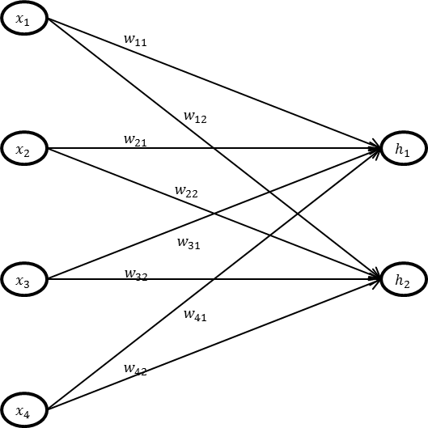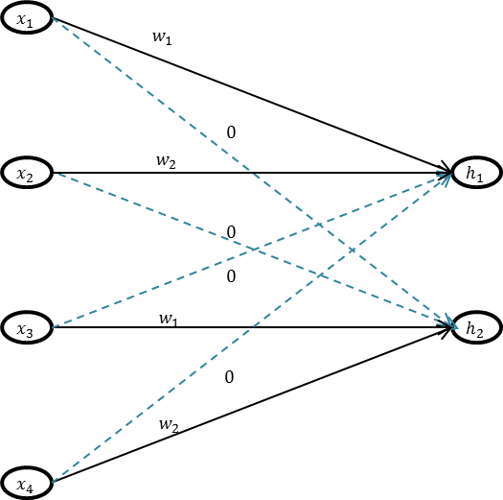Consider 1D input space of 4 elements, $x=(x_{1}, x_{2},{ x}_{3},{ x}_{4})$ and single 1D kernel or weight matrix of size 2, having two non-zero elements, $w=(w_{1},{ w}_{2})$ to perform the convolutional operation with a stride of 2 (left of Figure 2).

**Figure 2: Convolutional layer with stride 2 (left) v/s fully connected layer (right)**

where in another case of fully connected layer weight matrix is having eight elements, $w$ = $(w_{11},{ w}_{12}, { w}_{21}, w_{22}, w_{31}, w_{32}, w_{41}, w_{42})$ (right of Figure 2)

To compute the output of the first neuron in hidden space of CNN, weights ( $w_{1},{ w}_{2},$*0 $,$* *0)* areneeded for dot product with input space $(x_{1}, x_{2},{ x}_{3},{ x}_{4})$ to get,

|  |  |  |
| --- | --- | --- |
|  | $$h_{1}= w_{1}.x_{1}+ w_{2}.x_{2}$$ | **3.3** |

While in the case of ANN weights $(w_{11},{ w}_{21}, w_{31}, w_{41})$ are needed for dot product with input space to get output,

|  |  |  |
| --- | --- | --- |
|  | $$h_{1}= w_{11}.x_{1}+ w_{21}.x_{2}+ w_{31}.x_{3}+ w_{41}.x_{4}$$ | **3.3** |

Similarly to compute the output of the second neuron in hidden space of CNN, weights (*0 $,$* *0, $w_{1},{ w}_{2}$)* areneeded for dot product with input space $(x_{1}, x_{2},{ x}_{3},{ x}_{4})$ to get,

|  |  |  |
| --- | --- | --- |
|  | $$h_{2}= w_{1}.x_{3}+ w_{2}.x_{4}$$ | **3.4** |

While in the case of ANN weights $(w_{12},{ w}_{22}, w_{32}, w_{42})$ are needed for dot product with input space to get output,

|  |  |  |
| --- | --- | --- |
|  | $$h_{2}= w_{12}.x_{1}+ w_{22}.x_{2}+ w_{32}.x_{3}+ w_{42}.x_{4}$$ | **3.5** |

So, it can be seen that the number of different weights and computational operations is far less on CNN when compared with ANN. This number can be further reduced by reducing the size of the filter, making the network computationally cheaper and efficient. Sometimes rows or columns of zeroes are added at the boundaries of input, called zero padding. Padding is useful to retain or adjust the dimension of the feature map after convolution.

After convolution operation, the dimension of the feature map isgiven by the formula,

|  |  |  |
| --- | --- | --- |
|  | $$d_{o}=\frac{d_{i}-f+2p }{s}+1$$ | **3.6** |

where,

$d_{o}=$ Dimension of the feature map

$d_{ i}=$ Dimension of the input space

$f =$ Size of the kernel

$p =$ Number of zero padding

$s =$ Stride of filter

### Batch Normlisation Layer

Batch Normalisation layer is often used between the Convolutional and activation function layers. It can be applied to any input or hidden layer. If H is the batch to be normalised, then H is replaced by,

|  |  |  |
| --- | --- | --- |
|  | $$H^{'}=\frac{H-µ}{ σ}$$ | **3.7** |

Where µ is mean of mini-batch, and $σ$ is its standard deviation. Subsequently $H^{'}$ scaled and shifted by learnable parameters γ and β, respectively. This technique of normalisation improved the speed of network training [27].

### Dropout Layer

Dropout is powerful as well as computationally inexpensive technique of regularisation [28].It is very effective for prevention of overfitting. In this technique, some neurons of previous layer are selected randomly. These selected neurons are then dropped out from the network for that iteration, i.e. weights of those neurons are forced to zero. This enforces data to flow through all nodes and train network to learn new features. Thus it makes network robust. One disadvantage one might face is that after using dropout, it may increase training time.

### Activation Functions

Activation functions are important parts of neural networks. They are used to introduce non-linearity in neural networks. Some of the popular activation functions are Logistic sigmoidal, Hyperbolic linear tangent, Rectified linear unit (ReLU). In deep networks, ReLU is a usual and popular choice due to low computational requirement and deterrence to vanishing gradient problem. Some of the common activation functions are described below.

1. Logistic sigmoidal activation function

|  |  |  |
| --- | --- | --- |
|  | $$h(x)=1/(1+e^{-x})$$ | **3.8** |

1. Hyperbolic linear tangent

|  |  |  |
| --- | --- | --- |
|  | $$h\left(x\right)=\left(\frac{2}{1+e^{-x}}\right)-1$$ | **3.9** |

1. Rectified linear unit

|  |  |  |
| --- | --- | --- |
|  | $h\left(x\right)=x$ for $x≥0$, $h\left(x\right)=0$ for $x<0$ | **3.10** |

where $x$ is input to activation function and $h$ is an output of it.

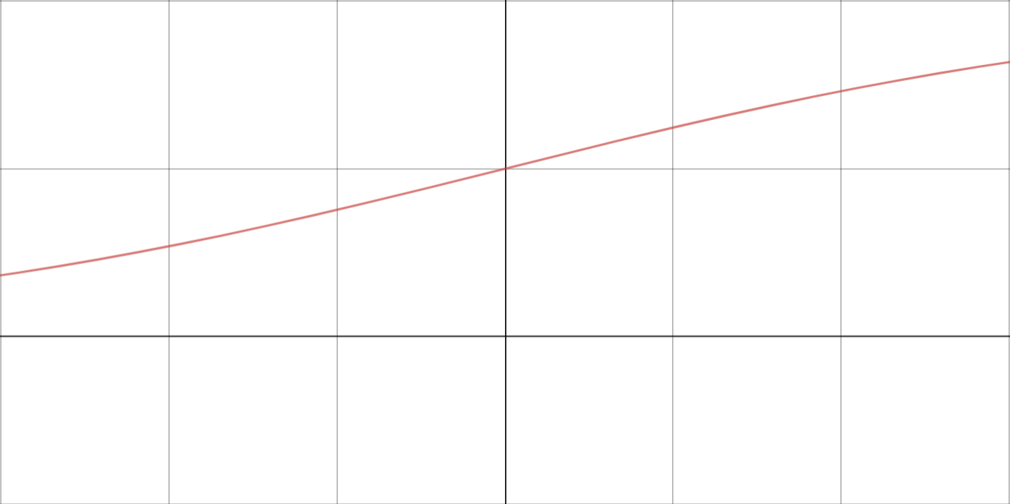

**Figure 3: Logistic Sigmoidal Function**

y

x

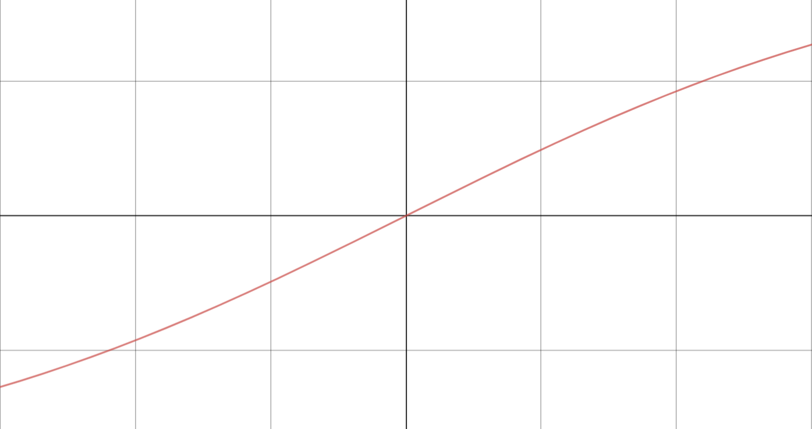

y

x

**Figure 4: Hyperbolic Linear Tangent Function**

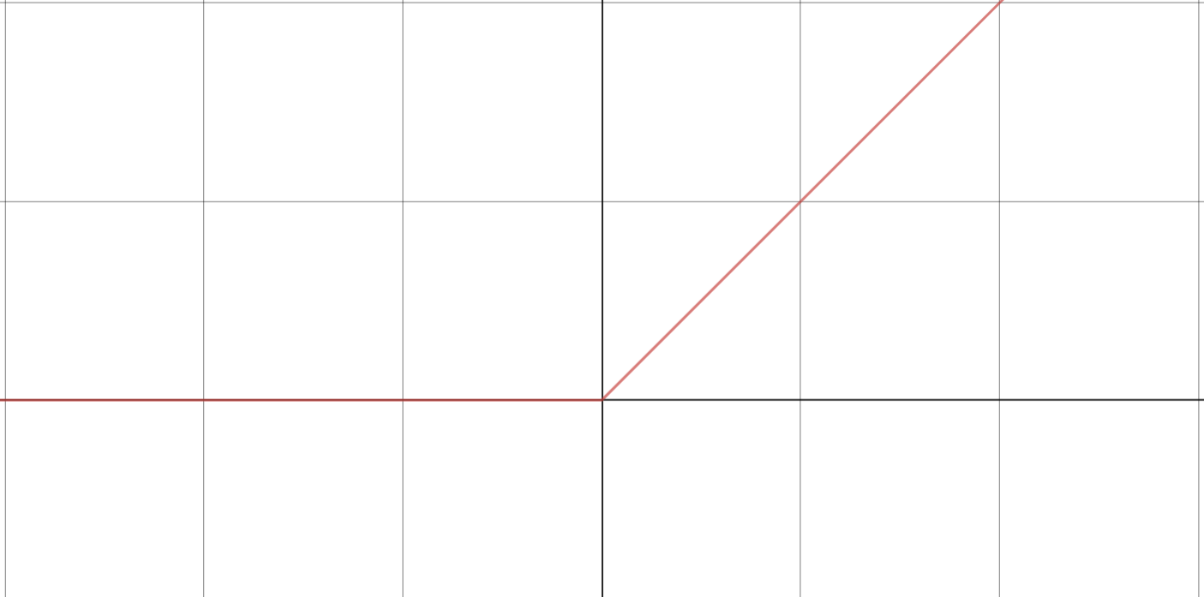

y

x

**Figure 5: ReLU Function**

### Multi-Label Classification

Multi-label classification is one of the supervised learning problems, in which an example may be associated with more than one target labels, unlike other conventional single-label classification problems such as multiclass classification and binary classification where one example is strictly associated with only one target label. In single label classification, all target labels are mutually exclusive. One such example of Single label classification is a prediction of movie ratings like ‘U’, ‘U/A’, ‘A’, etc. where all ratings are exclusive. In contrast, predictions of the genre of the movie like ‘action’, ‘comedy’, ‘drama’, ‘horror’, etc. is an example of a Multi-label classification where the film may have more than one genre. One of the common approaches to Multi-label classification is ‘problem transformation’ [29]. In this approach problem of Multi-label, classification is transformed into many or one single-label classification problems. Some of the problem transformation methods are discussed below.

1. **Label power set method**

In this approach, along with distinct labels, all of the combinations of distinct labels are also treated as new distinct labels. For all of these new and old labels, the multiclass classification model is trained. For example, let us consider three distinct, independent target labels or classes A, B, C, which a case may belong. Then the total Number of target classes by label power set method would be $2^{3}-1=7,$ which are as follows.

**Table 1: Sample Target Vector (Label Power Set Method)**

|  |  |
| --- | --- |
| **Class** | **Target Vector** |
| A | (1, 0, 0, 0, 0, 0, 0) |
| B | (0, 1, 0, 0, 0, 0, 0) |
| C | (0, 0, 1, 0, 0, 0, 0) |
| D (A & B) | (0, 0, 0, 1, 0, 0, 0) |
| E (A & C) | (0, 0, 0, 0, 1, 0, 0) |
| F (B & C) | (0, 0, 0, 0, 0, 1, 0) |
| G (A & B & C) | (0, 0, 0, 0, 0, 0, 1) |

As it can be seen that Number of classes increases exponentially with an increase in the number of distinct classes. Therefore this method is computationally expensive as well as challenging to implement. It is nearly impossible to collect data for all possible combinations even if the number of distinct labels exceeds ten because in that case number of the possible combination may be as high as 2047.

1. **Conversion to the binary classification problem**
2. **Single classifier approach**

In this approach, only one classifier is used to classify all labels. Difference between this approach and label power set method lies in target vectors. For the same three faults as discussed in Label power set method, Target vectors will be as follows.

**Table 2: Sample Target Vector (Binary classification Method)**

|  |  |
| --- | --- |
| **Class** | **Target Vector** |
| A | (1, 0, 0) |
| B | (0, 1, 0) |
| C | (0, 0, 1) |
| A & B | (1, 1, 0) |
| A & C | (1, 0, 1) |
| B & C | (0, 1, 1) |
| A & B & C | (1, 1, 1) |

In the last output layer, Sigmoid activation is used instead of Softmax activation, To perform binary classification. Softmax is generally used in typical Multiclass classification problem. This approach has less space complexity compared with label power set approach.

1. **Multiple classifier approach**

In this approach, multiple classifiers are trained to solve Multi-label classification problem. The number of classifiers is equal to the number of distinct labels present, where each classifier is associated with one particular label so that it will diagnose whether that label is present in that example. Each classifier can be tuned with different architecture, hyperparameters, epochs which gives more control in the training process. It may be handy in some cases as labels may need various features to be extracted for detection. Thus this approach is better than one classifier approach.

### Remarks

In this chapter, ANN & CNN are comparatively analysed. Their general construction and working is discussed. The number of different weights and computational operations is far less on CNN when compared with ANN. Dropout, activation functions like ReLU discussed. Problem of Multi-label classification is introduced and two major methods for solving it were discussed which are label power set method & binary relevance method. In next chapter information about rotor system, its faults and data is given.

## ROTOR SYSTEM & DATA

Vibration response data is generally used for condition monitoring of rotor systems. The current study involves a diagnosis of Multi-label or composite faults which were simulated on Machine Fault Simulator (MFS).

### Machine Fault Simulator

Data has been acquired by conducting experiments on a Machine Fault Simulator. J. Singh [3] carried out set-up, instrumentation and data collection which is briefly discussed below, for reference.

Accelerometers and proximity sensors were used for acquiring vibration signals from different subsystems of the rotor test rig. Accelerometers and charge amplifier used were of Bruel and Kjaer make, model 4374. Proximity sensors used were of Bentley Nevada make, Model 3300 Ram. The Machine Fault Simulator consists of a DC motor which drives a shaft supported by roller bearings. On the shaft, two rotors can be mounted at desired locations. Rotor shaft and motor are connected by flexible coupling to compensate misalignment and absorb undesirable shocks. Operating speed, as well as the acceleration of the motor, can be controlled. The DC motor can be operated up to a speed of 6000 RPM or 100 Hz.

### Rotor System & Data Acquisition

A typical rotor system can be divided into three categories of subsystems as follows.

1. **Stationary**

It includes subsystems like casing and foundations,

1. **Circulatory**

It includes the lubrication system.

1. **Rotational**

It includes subsystems like bearing housing, gearbox, shaft rotor subassembly, motor, couplings.

Placement of sensors is a crucial stage in data acquisition. Generally, most of the faults occur in the rotational category. Therefore sensors were placed at (i) gearbox (ii) bearing housing and (iii) shaft rotor assembly. At each of these three locations, two sensors were mounted, mutually perpendicular to each other (vertical & horizontal). Proximity sensors were used near shaft rotor assembly and accelerometers at gearbox and bearing housing. Data acquisition card and LabVIEW software were used to collect data using six sensors. Vibration data was collected at 2560 samples/sec. Following parameters were set at the time of data collection.

1. Operating speed = 40 Hz or 2400 RPM;
2. Sampling rate = 2560 samples/sec;
3. Number of data points for one example = 4096;

Time of one experiment = 1.6 seconds

### Types of Faults

Different kinds of faults were introduced in Machine Fault Simulator by Jasdeep Singh at a constant operating speed of 40 Hz. For each fault, 20 experiments were conducted for 1.6 seconds each, and time-domain data was acquired. Following faults were introduced in the system.

1. **No fault**

A signal was collected when none of the faults was simulated in Machine Fault Simulator under normal working conditions.

1. **Unbalance**

An unbalance mass of 6.82 grams was introduced on the right disk. Unbalance fault causes extra radial harmonic reaction forces in components like bearings. The amplitude

of this force is directly proportional to the square of the operating speed of the Rotor. As a result, there may be excessive wear in busing, bearing and other rotating parts which reduces service life.

1. **Eccentric Rotor**

This fault is very similar to unbalance fault, where there is eccentricity between mass and geometric centres. To introduce this fault, the eccentric disc provided by the manufacturer was used instead of a healthy disc.

1. **Cocked Rotor**

In this fault, the axis of the shaft is at a non-zero angle with the perpendicular of the plane of the rotor. To introduce this fault right disc was replaced by a cocked disc which is bored slightly off-centre to the shaft.

1. **Missing Tooth**

For the simulation of this fault, defective pinion provided by the manufacturer, with one missing tooth was installed in the gearbox instead of the good pinion.

1. **Loose Gear**

The good gear was replaced by loose gear for this case.

1. **Bearing defects**

The standard bearing was replaced with defective ones, and three bearing faults were simulated which are bearing inner race fault, baring outer racer fault and ball spin fault. The roller bearing rotates at speeds proportional to the rotational speed of the shaft. Therefore, specific characteristic frequencies can be attributed to the faults occurring in the individual elements of the bearing [30].

The fundamental defect frequency associated with inner race fault is given by,

|  |  |  |
| --- | --- | --- |
|  | $$f=\frac{S N}{2}\left(1+\frac{d_{b }}{d_{p}}\cos\left(∅\right))\right)$$ | **4.1** |

The fundamental defect frequency associated with outer race fault is given by,

|  |  |  |
| --- | --- | --- |
|  | $$f=\frac{S N}{2}\left(1-\frac{d_{b }}{d_{p}}\cos\left(∅\right))\right)$$ | **4.2** |

The fundamental defect frequency associated with ball spin fault is given by,

|  |  |  |
| --- | --- | --- |
|  | $$f=\frac{S d_{p}}{2 d_{b }}\left(1-{\left(\frac{d_{b }}{d_{p}}\right)}^{2}{(\cos\left(∅\right))}^{2}\right)$$ | **4.3** |

where,

$S$ = Operating frequency of the shaft (40 Hz in the current case),

$N$ = Number of balls in the bearing,

$d_{b }$ = Diameter of ball

$d_{p}$ = Pitch diameter of the bearing

$∅$ = bearing load contact angle (degrees)

$Thus$ Frequencies calculated by above formulas are 200 Hz for inner race defect, 120 Hz for outer race defect, and nearly 75 Hz for ball spin fault.



a) Bearing (Vertical Sensor)



b) Bearing (Horizontal Sensor)

**

c) Gear (Vertical Sensor)



d) Gear (Horizontal Sensor)

e) Shaft (Vertical Sensor )

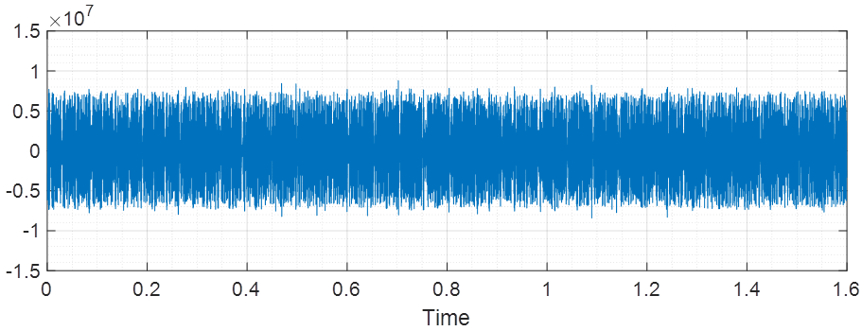

f) Shaft (Horizontal Sensor)

**Figure 6: A Typical Response from Sensors for a Particular Fault**

Two kind of datasets were generated for analysis. First one, distinct fault dataset, and the second is combined fault dataset. The twelve distinct faults for the dataset (Set 1) are described in table 3. Another dataset (Set 2) comprised of combined faults. The combined faults have Missing Tooth as the common fault and other faults are - from fault number 5 in table 3. (Loose Gear) to 11 (Combined bearing Fault), making a total of seven combined faults as shown in.table 4.

|  |  |  |
| --- | --- | --- |
| **S NO.** | **FAULT** | **SOURCE OF THE FAULT** |
| 1 | NO FAULT | NO SOURCE |
| 2 | LOOSE BELT | BELT |
| 3 | TIGHT BELT |
| 4 | MISSING TOOTH | GEARBOX |
| 5 | LOOSE GEAR |
| 6 | UNBALANCE (6.82 GMS) | SHAFT |
| 7 | ECCENTRIC ROTOR |
| 8 | COCKED ROTOR |
| 9 | BEARING INNER RACE FAULT | BEARING |
| 10 | BEARING OUTER RACE FAULT |
| 11 | BALL SPIN FAULT |

**Table 3: Distinct Faults in Dataset 1**

|  |  |  |
| --- | --- | --- |
| **S NO.** | **FAULT** | **SOURCE OF THE FAULT** |
| *FAULTS COMBINED WITH MISSING TOOTH FAULT* | | |
| 1 | LOOSE GEAR | GEARBOX |
| 2 | UNBALANCE (6.82 GMS) | GEARBOX & SHAFT |
| 3 | ECCENTRIC ROTOR |
| 4 | COCKED ROTOR |
| 5 | BEARING INNER RACE FAULT | GEARBOX & BEARING |
| 6 | BEARING OUTER RACE FAULT |
| 7 | BALL SPIN FAULT |

**Table 4: Combined Faults in Dataset 2**

### Remarks

In this chapter, rotor system is introduced. Information regarding sensors, operating conditions, data, sampling rate is given. Different distinct and combined faults that occurs generally in rotor system are discussed. Plot of a typical response of particular fault is given. In next chapter, methodology for solving Multi-label classification problem is discussed.

## NETWORK ARCHITECTURES, TRAINING & VALIDATION

|  |  |
| --- | --- |
| **Network** | **Fault to be diagnosed by the network** |
| G | ECCENTRIC ROTOR |
| H | COCKED ROTOR |
| I | BEARING INNER RACE FAULT |
| J | BEARING OUTER RACE FAULT |
| K | BALL SPIN FAULT |

Multiple binary classifier/network approach is used for Multi-label classification, as discussed in section 3.7. As there are eleven distinct types of faults, eleven different classifiers are trained associated with one particular defect to detect whether it is present or not in a given signal. For training and validation, distinct fault data is used, that is of dataset 1. After training, combined fault data (data in dataset 2) is used for testing purposes. For training, testing & validation; raw time domain data was used. 80% of dataset 1 is used for training, and the remaining 20% is used for validation. Network training is performed with Adaptive moment estimation (Adam) algorithm. As Number of training examples is small, instead of mini-batch full batch of training examples was used for error computation. Other hyperparameters like number of epochs and learning rate were tuned differently for each classifier. Following eleven networks are trained to diagnose one fault each as shown in the following table.

**Table 5: Networks**

|  |  |
| --- | --- |
| **Network** | **Fault to be diagnosed by the network** |
| A | NO FAULT |
| B | LOOSE BELT |
| C | TIGHT BELT |
| D | MISSING TOOTH |
| E | LOOSE GEAR |
| F | UNBALANCE |

For simplicity, combined faults are named as follows.

1. Missing Tooth & Loose Gear = Fault ‘1.’
2. Missing Tooth & Unbalance = Fault ‘2.’
3. Missing Tooth & Eccentric Rotor = Fault ‘3.’
4. Missing Tooth & Cocked Rotor = Fault ‘4.’
5. Missing Tooth & Bearing Inner Race Fault = Fault ‘5.’
6. Missing Tooth & Bearing Outer Race Fault = Fault ‘6.’
7. Missing Tooth & Ball Spin Fault = Fault ‘7.’

Network architectures of classifiers are discussed below.

|  |  |  |  |  |  |
| --- | --- | --- | --- | --- | --- |
| **Sr.No** | **Layer** | **Kernel Size/ Input**  **Shape** | **# of Kernels/ Neurons** | **Vertical Stride** | **Horizontal Stride** |
| 1 | Input | $$4096×2×3$$ | - | - |  |
| 2 | Convolution | $$64×1$$ | 12 | 64 | 1 |
| 3 | Batch Normalization | - | - | - |  |
| 4 | ReLU | - | - | - | - |
| 5 | Dropout | - | - | - | - |
| 6 | Convolution | $$64×2$$ | 12 | 1 | 1 |
| 7 | Batch Normalisation | - | - | - |  |
| 8 | ReLU | - | - | - | - |
| 9 | Dropout | - | - | - | - |
| 10 | Fully Connected | - | 1 | - | - |
| 11 | Sigmoid | - | - | - | - |

**Table 6: Network (A) for the detection of ‘No Fault.’**

**Table 7: Network (B) for the detection of ‘Loose Belt.’**

|  |  |  |  |  |  |
| --- | --- | --- | --- | --- | --- |
| **Sr.No** | **Layer** | **Kernel Size/ Input**  **Shape** | **# of Kernels/ Neurons** | **Vertical Stride** | **Horizontal Stride** |
| 1 | Input | $$4096×2×3$$ | - | - |  |
| 2 | Convolution |  | 12 | 64 | 1 |
| 3 | Batch Normalization | - | - | - |  |
| 4 | ReLU | - | - | - | - |
| 5 | Dropout | - | - | - | - |
| 6 | Convolution | $$64×2$$ | 12 | 1 | 1 |
| 7 | Batch Normalisation | - | - | - |  |
| 8 | ReLU | - | - | - | - |
| 9 | Dropout | - | - | - | - |
| 10 | Fully Connected | - | 1 | - | - |
| 11 | Sigmoid | - | - | - | - |

**Table 8: Network (C) for the detection of ‘Tight Belt.’**

|  |  |  |  |  |  |
| --- | --- | --- | --- | --- | --- |
| **Sr.No** | **Layer** | **Kernel Size/ Input**  **Shape** | **# of Kernels/ Neurons** | **Vertical Stride** | **Horizontal Stride** |
| 1 | Input | $$4096×2×3$$ | - | - |  |
| 2 | Convolution |  | 12 | 64 | 1 |
| 3 | Batch Normalization | - | - | - |  |
| 4 | ReLU | - | - | - | - |
| 5 | Dropout | - | - | - | - |
| 6 | Convolution | $$64×2$$ | 12 | 1 | 1 |
| 7 | Batch Normalisation | - | - | - |  |
| 8 | ReLU | - | - | - | - |
| 9 | Dropout | - | - | - | - |
| 10 | Fully Connected | - | 1 | - | - |
| 11 | Sigmoid | - | - | - | - |

**Table 9: Network (D) for the detection of ‘Missing Tooth’**

|  |  |  |  |  |  |
| --- | --- | --- | --- | --- | --- |
| **Sr.No** | **Layer** | **Kernel Size/ Input**  **Shape** | **# of Kernels/ Neurons** | **Vertical Stride** | **Horizontal Stride** |
| 1 | Input | $$4096×2×1$$ | - | - |  |
| 2 | Convolution | $$64×1$$ | 12 | 64 | 1 |
| 3 | Batch Normalization | - | - | - |  |
| 4 | ReLU | - | - | - | - |
| 5 | Dropout | - | - | - | - |
| 6 | Convolution | $$64×2$$ | 12 | 1 | 1 |
| 7 | Batch Normalisation | - | - | - |  |
| 8 | ReLU | - | - | - | - |
| 9 | Dropout | - | - | - | - |
| 10 | Fully Connected | - | 1 | - | - |
| 11 | Sigmoid | - | - | - | - |

**Table 10: Network (E) for the detection of ‘Loose Gear.’**

|  |  |  |  |  |  |
| --- | --- | --- | --- | --- | --- |
| **Sr.No** | **Layer** | **Kernel Size/ Input**  **Shape** | **# of Kernels/ Neurons** | **Vertical Stride** | **Horizontal Stride** |
| 1 | Input | $$4096×2×1$$ | - | - |  |
| 2 | Convolution | $$128×1$$ | 12 | 64 | 1 |
| 3 | Batch Normalization | - | - | - |  |
| 4 | ReLU | - | - | - | - |
| 5 | Dropout | - | - | - | - |
| 6 | Convolution | $$63×2$$ | 12 | 1 | 1 |
| 7 | Batch Normalisation | - | - | - |  |
| 8 | ReLU | - | - | - | - |
| 9 | Dropout | - | - | - | - |
| 10 | Fully Connected | - | 1 | - | - |
| 11 | Sigmoid | - | - | - | - |

**Table 11: Network (F) for the detection of ‘Unbalance.’**

|  |  |  |  |  |  |
| --- | --- | --- | --- | --- | --- |
| **Sr.No** | **Layer** | **Kernel Size/ Input**  **Shape** | **# of Kernels/ Neurons** | **Vertical Stride** | **Horizontal Stride** |
| 1 | Input | $$4096×2×1$$ | - | - |  |
| 2 | Convolution | $$128×1$$ | 12 | 64 | 1 |
| 3 | Batch Normalization | - | - | - |  |
| 4 | ReLU | - | - | - | - |
| 5 | Dropout | - | - | - | - |
| 6 | Convolution | $$63×2$$ | 12 | 1 | 1 |
| 7 | Batch Normalisation | - | - | - |  |
| 8 | ReLU | - | - | - | - |
| 9 | Dropout | - | - | - | - |
| 10 | Fully Connected | - | 1 | - | - |
| 11 | Sigmoid | - | - | - | - |

**Table 12: Network (G) for the detection of ‘Eccentric Rotor.’**

|  |  |  |  |  |  |
| --- | --- | --- | --- | --- | --- |
| **Sr.No** | **Layer** | **Kernel Size/ Input**  **Shape** | **# of Kernels/ Neurons** | **Vertical Stride** | **Horizontal Stride** |
| 1 | Input | $$4096×2×1$$ | - | - |  |
| 2 | Convolution | $$128×1$$ | 12 | 64 | 1 |
| 3 | Batch Normalization | - | - | - |  |
| 4 | ReLU | - | - | - | - |
| 5 | Dropout | - | - | - | - |
| 6 | Convolution | $$63×2$$ | 12 | 1 | 1 |
| 7 | Batch Normalisation | - | - | - |  |
| 8 | ReLU | - | - | - | - |
| 9 | Dropout | - | - | - | - |
| 10 | Fully Connected | - | 1 | - | - |
| 11 | Sigmoid | - | - | - | - |

**Table 13: Network (H) for the detection of ‘Cocked Rotor.’**

|  |  |  |  |  |  |
| --- | --- | --- | --- | --- | --- |
| **Sr.No** | **Layer** | **Kernel Size/ Input**  **Shape** | **# of Kernels/ Neurons** | **Vertical Stride** | **Horizontal Stride** |
| 1 | Input | $$4096×1×1$$ | - | - |  |
| 2 | Convolution | $$32×1$$ | 12 | 32 | 1 |
| 3 | Batch Normalization | - | - | - |  |
| 4 | ReLU | - | - | - | - |
| 5 | Dropout | - | - | - | - |
| 6 | Convolution | $$64×1$$ | 12 | 8 | 1 |
| 7 | Batch Normalisation | - | - | - |  |
| 8 | ReLU | - | - | - | - |
| 9 | Dropout | - | - | - | - |
| 6 | Convolution | $$4×1$$ | 12 | 4 | 1 |
| 7 | Batch Normalisation | - | - | - |  |
| 8 | ReLU | - | - | - | - |
| 9 | Dropout | - | - | - | - |
| 6 | Convolution | $$1×1$$ | 12 | 1 | 1 |
| 7 | Batch Normalisation | - | - | - |  |
| 8 | ReLU | - | - | - | - |
| 9 | Dropout | - | - | - | - |
| 10 | Fully Connected | - | 1 | - | - |
| 11 | Sigmoid | - | - | - | - |

**Table 14: Network (I) for the detection of ‘Bearing Inner Race Fault.’**

|  |  |  |  |  |  |
| --- | --- | --- | --- | --- | --- |
| **Sr.No** | **Layer** | **Kernel Size/ Input**  **Shape** | **# of Kernels/ Neurons** | **Vertical Stride** | **Horizontal Stride** |
| 1 | Input | $$4096×2×1$$ | - | - |  |
| 2 | Convolution | $$32×1$$ | 12 | 32 | 1 |
| 3 | Batch Normalization | - | - | - |  |
| 4 | ReLU | - | - | - | - |
| 5 | Dropout | - | - | - | - |
| 6 | Convolution | $$64×1$$ | 12 | 8 | 1 |
| 7 | Batch Normalisation | - | - | - |  |
| 8 | ReLU | - | - | - | - |
| 9 | Dropout | - | - | - | - |
| 10 | Convolution | $$4×1$$ | 12 | 4 | 1 |
| 11 | Batch Normalisation | - | - | - |  |
| 12 | ReLU | - | - | - | - |
| 13 | Dropout | - | - | - | - |
| 6 | Convolution | $$1×2$$ | 12 | 1 | 1 |
| 7 | Batch Normalisation | - | - | - |  |
| 8 | ReLU | - | - | - | - |
| 9 | Dropout | - | - | - | - |
| 10 | Fully Connected | - | 1 | - | - |
| 11 | Sigmoid | - | - | - | - |

|  |  |  |  |  |  |
| --- | --- | --- | --- | --- | --- |
| **Sr.No** | **Layer** | **Kernel Size/ Input**  **Shape** | **# of Kernels/ Neurons** | **Vertical Stride** | **Horizontal Stride** |
| 1 | Input | $$4096×1×1$$ | - | - |  |
| 2 | Convolution | $$16×1$$ | 12 | 16 | 1 |
| 3 | Batch Normalization | - | - | - |  |
| 4 | ReLU | - | - | - | - |
| 5 | Dropout | - | - | - | - |
| 6 | Convolution | $$16×1$$ | 12 | 16 | 1 |
| 7 | Batch Normalisation | - | - | - |  |
| 8 | ReLU | - | - | - | - |
| 9 | Dropout | - | - | - | - |
| 10 | Convolution | $$16×1$$ | 12 | 16 | 1 |
| 11 | Batch Normalisation | - | - | - |  |
| 12 | ReLU | - | - | - | - |
| 13 | Dropout | - | - | - | - |
| 10 | Fully Connected | - | 1 | - | - |
| 11 | Sigmoid | - | - | - | - |

**Table 15: Network (J) for the detection of ‘Bearing Outer Race Fault.'**

**Table 16: Network (K) for the detection of ‘Ball Spin Fault.’**

|  |  |  |  |  |  |
| --- | --- | --- | --- | --- | --- |
| **Sr.No** | **Layer** | **Kernel Size/ Input**  **Shape** | **# of Kernels/ Neurons** | **Vertical Stride** | **Horizontal Stride** |
| 1 | Input | $$4096×2×1$$ | - | - |  |
| 2 | Convolution | $$16×1$$ | 6 | 16 | 1 |
| 3 | Batch Normalization | - | - | - |  |
| 4 | ReLU | - | - | - | - |
| 5 | Dropout | - | - | - | - |
| 6 | Convolution | $$8×1$$ | 6 | 8 | 1 |
| 7 | Batch Normalisation | - | - | - |  |
| 8 | ReLU | - | - | - | - |
| 9 | Dropout | - | - | - | - |
| 10 | Convolution | $$8×1$$ | 6 | 8 | 1 |
| 11 | Batch Normalisation | - | - | - |  |
| 12 | ReLU | - | - | - | - |
| 13 | Dropout | - | - | - | - |
| 6 | Convolution | $$4×2$$ | 6 | 4 | 1 |
| 7 | Batch Normalisation | - | - | - |  |
| 8 | ReLU | - | - | - | - |
| 9 | Dropout | - | - | - | - |
| 10 | Fully Connected | - | 1 | - | - |
| 11 | Sigmoid | - | - | - | - |



**Convol. 1+ Activ. 1**

**Kernel: (64 1 3) × 12**

**Convol. 2+ Activ. 2**

**Kernel: (64 2 12) × 12**



**Fully connected layer**

**Bearing**

**Gear**

**Shaft**

**Figure 7: Network Architecture (A)**



**Convol. 1+ Activ. 1**

**Kernel: (64 1 3) × 12**

**Convol. 2+ Activ. 2**

**Kernel: (64 2 12) × 12**



**Fully connected layer**

**Bearing**

**Gear**

**Shaft**

**Figure 8: Network Architecture (B)**



**Convol. 1+ Activ. 1**

**Kernel: (64 1 3) × 12**

**Convol. 2+ Activ. 2**

**Kernel: (64 2 12) × 12**



**Fully connected layer**

**Bearing**

**Gear**

**Shaft**



**Convol. 1+ Activ. 1**

**Kernel: (64 1 1) × 12**

**Convol. 2+ Activ. 2**

**Kernel: (64 2 12) × 12**



**Fully connected layer**

**Gear**

**Figure 9: Network Architecture (C)**

**Figure 10: Network Architecture (D)**

**Figure 11: Network Architecture (E)**



**Convol. 1+ Activ. 1**

**Kernel: (128 1 1) × 12**

**Convol. 2+ Activ. 2**

**Kernel: (63 2 12) × 12**



**Fully connected layer**

**Shaft**



**Convol. 1+ Activ. 1**

**Kernel: (128 1 1) × 12**

**Convol. 2+ Activ. 2**

**Kernel: (63 2 12) × 12**



**Fully connected layer**

**Gear**

**Figure 12: Network Architecture (F)**



**Convol. 1+ Activ. 1**

**Kernel: (128 1 1) × 12**

**Convol. 2+ Activ. 2**

**Kernel: (63 2 12) × 12**



**Fully connected layer**

**Shaft**



**Convol. 1+ Activ. 1**

**Kernel: (32 1 1) × 12**

**Convol. 2+ Activ. 2**

**Kernel: (64 1 12) × 12**



**Fully connected layer**

**Convol. 3+ Activ. 3**

**Kernel: (4 1 12) × 12**

**Convol. 4+ Activ. 4**

**Kernel: (1 1 12) × 12**



**Shaft**

**Figure 13: Network Architecture (G)**

**Figure 14: Network Architecture (H)**

**Figure 15: Network Architecture (I)**

**Figure 16: Network Architecture (J)**



**Convol. 1+ Activ. 1**

**Kernel: (16 1 1) × 12**

**Convol. 2+ Activ. 2**

**Kernel: (16 1 12) × 12**



**Fully connected layer**

**Convol. 3+ Activ. 3**

**Kernel: (16 1 12) × 12**



**Bearing**



**Convol. 1+ Activ. 1**

**Kernel: (32 1 1) × 12**

**Convol. 2+ Activ. 2**

**Kernel: (64 1 12) × 12**



**Fully connected layer**

**Convol. 3+ Activ. 3**

**Kernel: (4 1 12) × 12**

**Convol. 4+ Activ. 4**

**Kernel: (1 2 12) × 12**



**Bearing**



**Convol. 1+ Activ. 1**

**Kernel: (16 1 1) × 6**

**Convol. 2+ Activ. 2**

**Kernel: (8 1 12) × 6**



**Fully connected layer**

**Convol. 3+ Activ. 3**

**Kernel: (8 1 12) × 6**

**Convol. 4+ Activ. 4**

**Kernel: (1 2 12) × 6**



**Bearing**

**Figure 17: Network Architecture (K)**

### Network Architectures & Results

Operating frequency of the system is 40 Hz. Length of a particular signal is 1.6 sec or 4096 points (in an input space). Therefore there is a new cycle after 64 points (in an input space). All network architectures were designed considering this operating condition.

For network A (to detect ‘No Fault’ condition), sensor data from all three locations (bearing, gear, shaft) was used. For first convolution layer, kernels of dimension (64 1) with vertical stride of 64 were used to analyse one cycle of rotation. Other hyperparameters in all networks were tunned heuristically. Same architecture was used to train network B & network C. Similar architecture was used to train network D (to detect ‘Missing Tooth’) except data used was only from location near to gearbox.

For networks E, F & G kernels with dimension (128 1) of stride 64 were used in the first convolution layer. For network E sensor data near gearbox was used, while for networks F & G data proximaty sensors located near shaft was used for training. For training network H, data from sensors located near shaft was used. For networks H & I kernels with dimension (32 1) of stride 32 were used in the first convolution layer. For networks I, J,& K data from accelerometer sensors located near bearing was used for training. For networks J & K kernel with dimension (16 1) of stride 16 were used in the first convolution layer to capture higher frequencies.

In all networks Dropout layers were used to prevent overitting. ReLU activation function was used after convolution layers and Sigmoid activation function was used in last fully connected layer for binary classification.

Following table is the evaluation metric for a combined performance of classifiers with respect to test data, i.e. combined faults data. Each combined fault has 20 examples. The following table shows number of examples of particular fault detected positive in certain network.

**Table 17: Modified Confusion matrix for combined faults**

|  |  |  |  |  |  |  |  |
| --- | --- | --- | --- | --- | --- | --- | --- |
| **FAULT**  **NETWORK** | **‘1’** | **‘2’** | **3’** | **‘4’** | **‘5’** | **‘6’** | **‘7’** |
| **A** | 00 | 00 | 00 | 00 | 00 | 00 | 00 |
| **B** | 00 | 00 | 00 | 00 | 00 | 00 | 00 |
| **C** | 00 | 00 | 00 | 00 | 00 | 00 | 00 |
| **D** | **20** | **20** | **18** | **20** | **19** | **20** | **17** |
| **E** | **18** | 00 | 00 | 00 | 00 | 00 | 00 |
| **F** | 00 | **01** | 00 | 00 | 00 | 00 | 00 |
| **G** | 00 | 00 | **20** | 00 | 00 | 00 | 00 |
| **H** | 00 | 00 | 00 | **01** | 00 | 00 | 00 |
| **I** | 00 | 00 | 00 | 00 | **20** | 00 | **09** |
| **J** | 00 | 00 | 00 | 00 | 00 | 00 | **05** |
| **K** | 00 | 00 | 00 | 00 | 00 | 00 | **04** |

As it can be seen from the above results that almost all examples of all combined faults are detected positive by network associated with ‘Missing Tooth Fault’ (Network-D). So it can be said that one component of every combine fault which is ‘Missing Tooth’ Fault is successfully diagnosed. Now for fault ‘1’, another component which is ‘Loose Gear’ is also detected successfully by Network-E. In case of Fault ‘2’, for other components ‘Unbalance’ only one example is detected positive. In the case of fault ‘3’ component “Eccentric Rotor’ is successfully detected in Network-G. Similar to fault ‘2’, only one example is successfully diagnosed as ‘Cocked Rotor’ by Network-H in case of fault ‘4’. For fault ‘5’ all instances are successfully diagnosed as ‘Bearing Inner Race Fault’. The second component of fault ‘5’ which is ‘Bearing Outer Race Fault’ is not at all detected in Network-J. For the last combined fault, four examples are detected correctly by Network-K. But along with it, nine examples of it are detected by Network-I and five examples detected by Network-J as false positive.

### Remarks

To solve Multi-label classification problem, multiple binary classifier/network approach is used. Eleven different classifiers are trained associated with one particular defect to detect whether it is present or not in a given signal. For training, testing & validation; raw time domain data was used. Network training is performed with Adaptive moment estimation (Adam) algorithm. As Number of training examples is small, instead of mini-batch full batch of training examples was used for error computation. Two out of seven combined faults were successfully classified and others were partially classified. These results are analysed using STFT in next chapter.

## STFT ANALYSIS

Application of the Short-Time Fourier Transform (STFT) to vibration signatures is done here, to understand combined faults classification results obtained using the method of multiple classifiers. It can be said that STFT is a combination of time-domain & frequency domain plot of a signal. It gives the information about the contribution of different frequencies composing a signal, along with the time interval during which these frequencies exist in the signal. Therefore STFT is a useful tool to analyse the variation of frequencies along with time.

The window function is a mathematical function that is zero-valued outside a chosen interval. It slides over a region in time domain, to compute its ‘Discrete Fourier Transform’ and subsequently STFT.

The resolution of the STFT plot depends on the size of the window function used in the analysis. The large size of window yields a high resolution of frequency but as a trade-off lower resolution of the time, and vice versa [31]. So the size of the window function should be selected as per the requirement of the problem. In the current problem, to analyse all examples at the same time, all 20 examples of each fault are joined together to form a joint signal. And then STFT of that signal is computed. For all faults ‘Hann’ window of length ‘512’ is used with the overlap of zero. For the STFT plot of combined Fault of ‘Loose Gear’, data from subsystem 1 (Gearbox) is used. In case of combined rotor defects, data from shaft sensors is used for STFT plots. For combined bearing defects, data from a sensor located at bearing housing is used,

### STFT Plots

STFT plots of all combined faults and their counterparts (distinct faults) are discussed in subsequent pages.

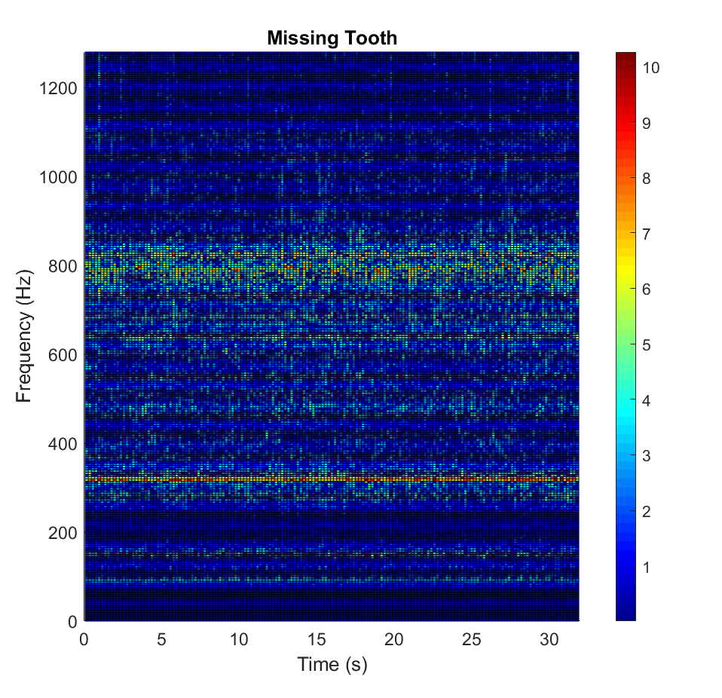 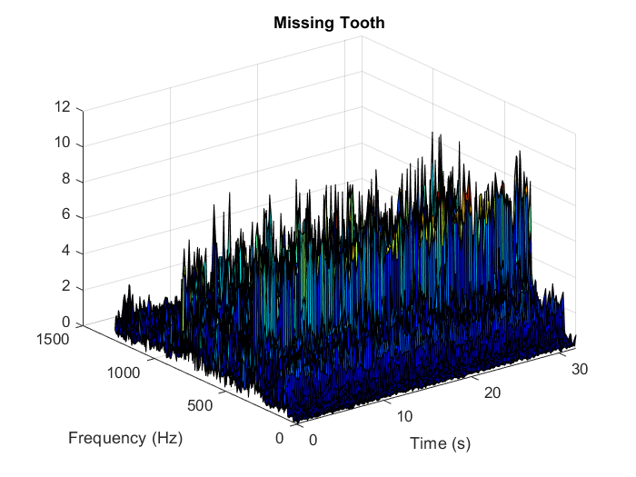

Figure 18: STFT plot of 'Missing Tooth Fault’, 3D (upper part), 2D (lower part)

**Figure 18: STFT plot of 'Missing Tooth Fault’, 3D (upper part), 2D (lower part)**

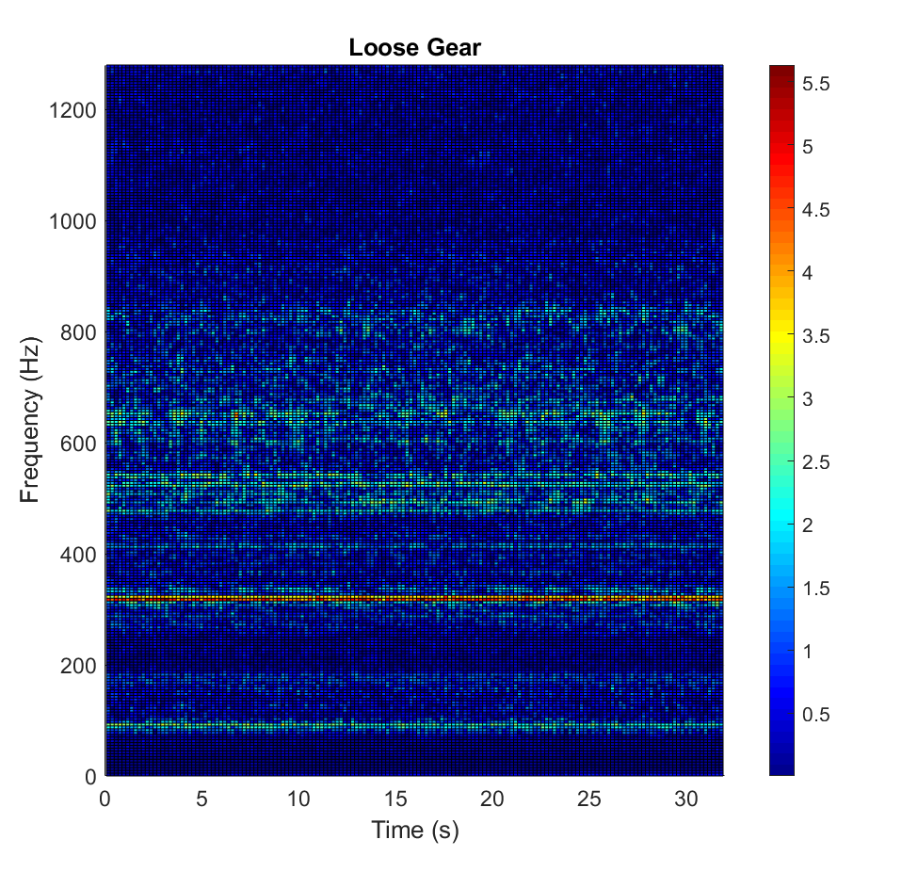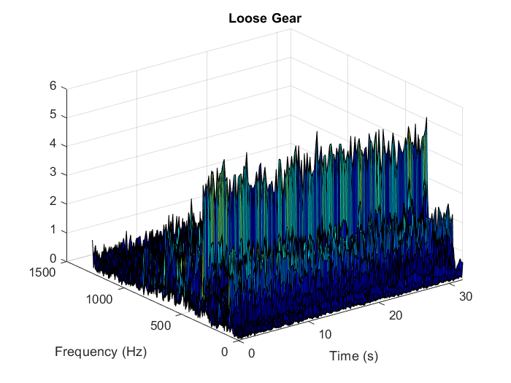

**Figure 19: STFT plot of 'Loose Gear Fault’, 3D (upper part), 2D (lower part)**

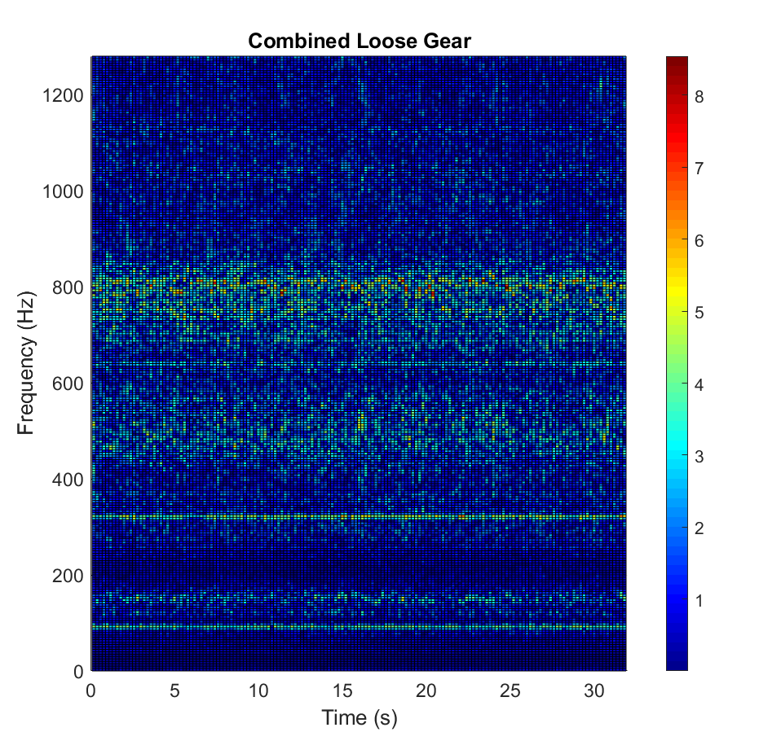**Figure 20: STFT plot of 'Combined Loose Gear Fault’, 3D (upper part), 2D (lower part)**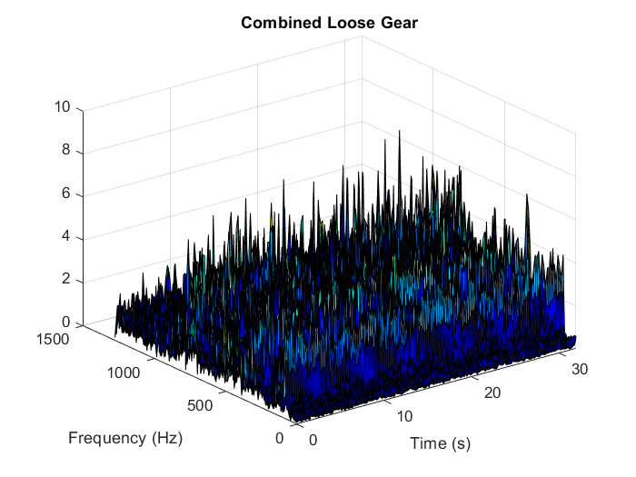

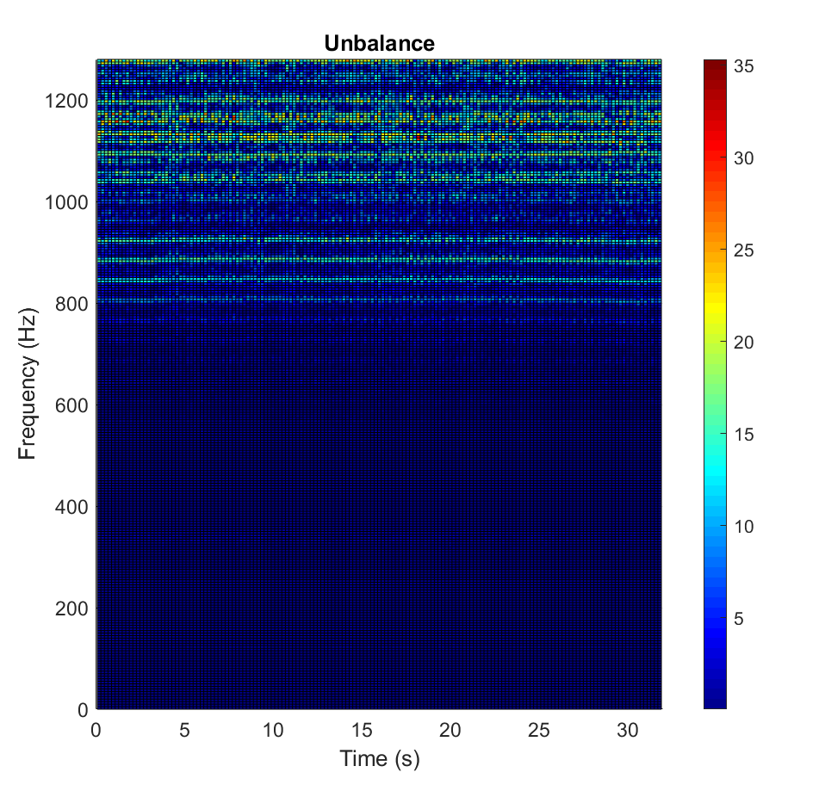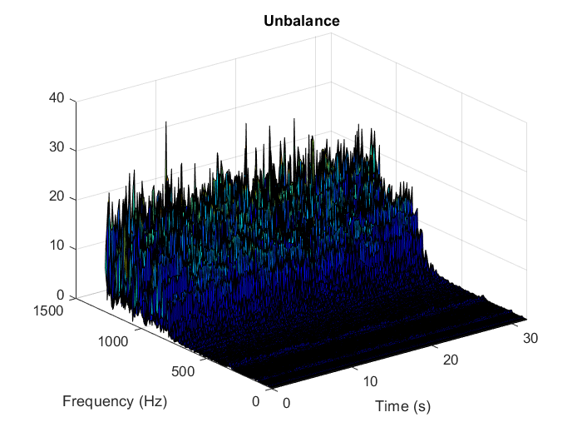

**Figure 21: STFT plot of 'Unbalance Fault’, 3D (upper part), 2D (lower part)**

**Figure 22: STFT plot of 'Combined Unbalance Fault’, 3D (upper part), 2D (lower part)**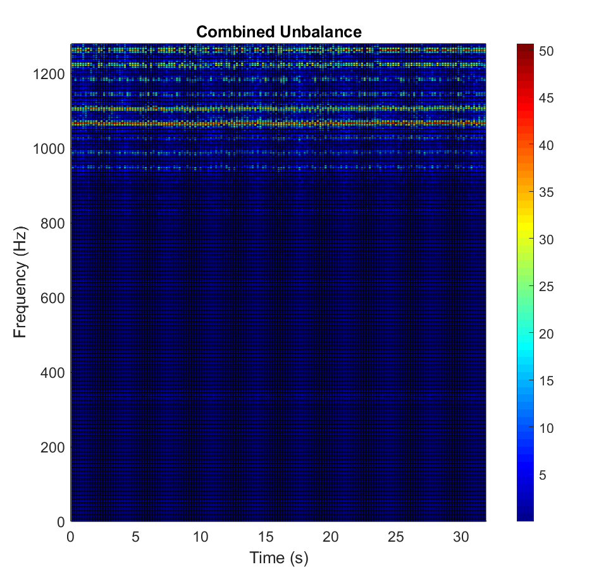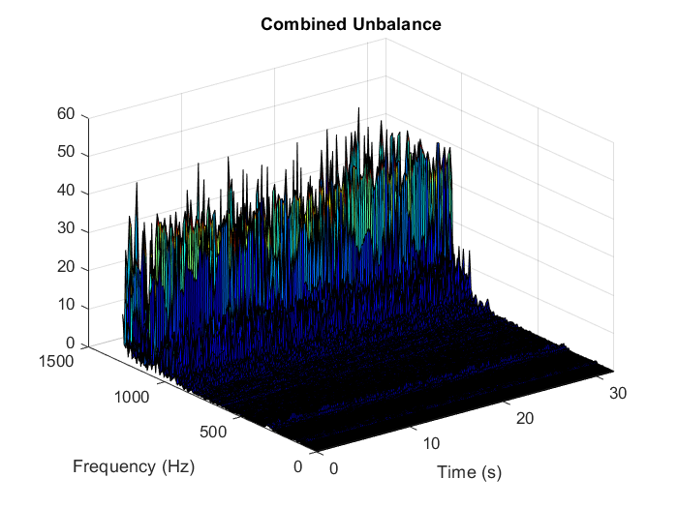

**Figure 23: STFT plot of 'Eccentric Rotor Fault’, 3D (upper part), 2D (lower part)**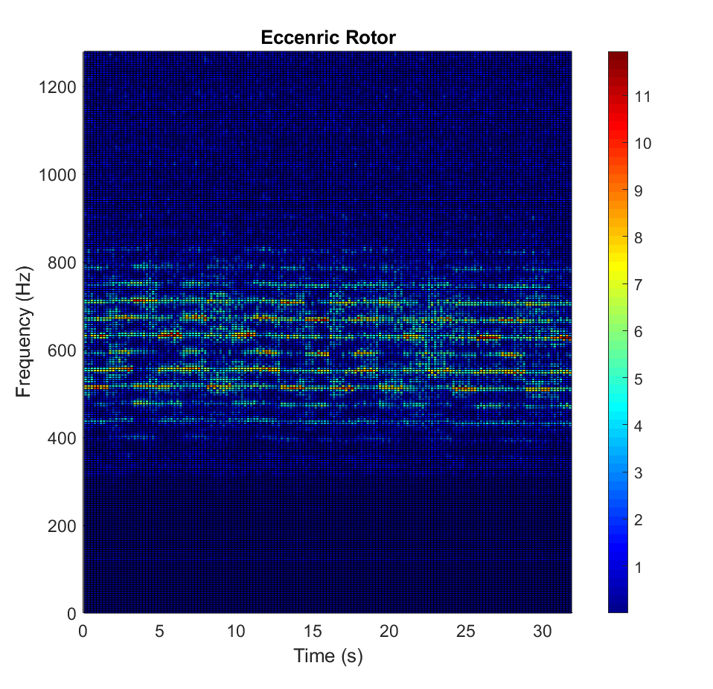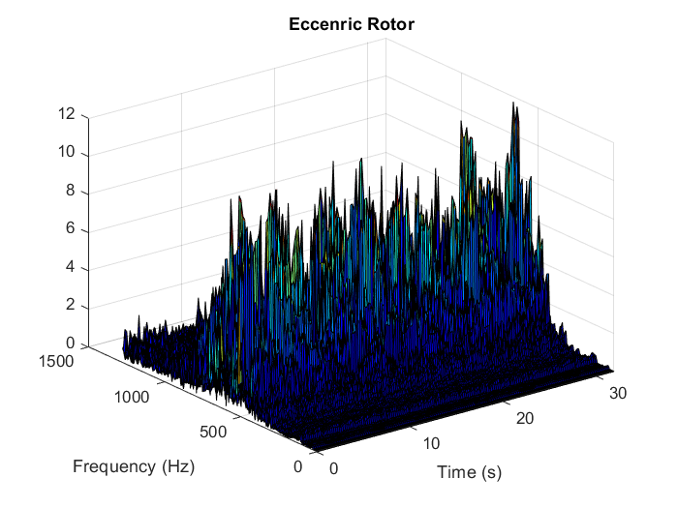

**Figure 24: STFT plot of 'Combined Eccentric Rotor Fault’, 3D (upper), 2D (lower part)**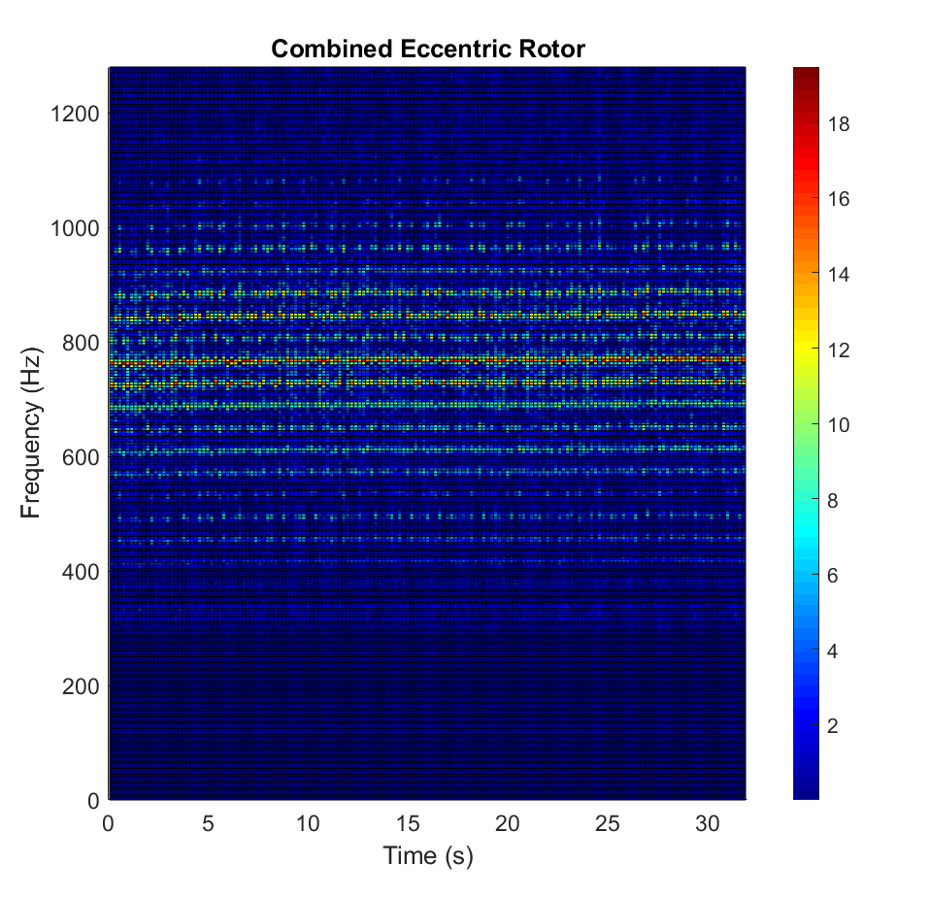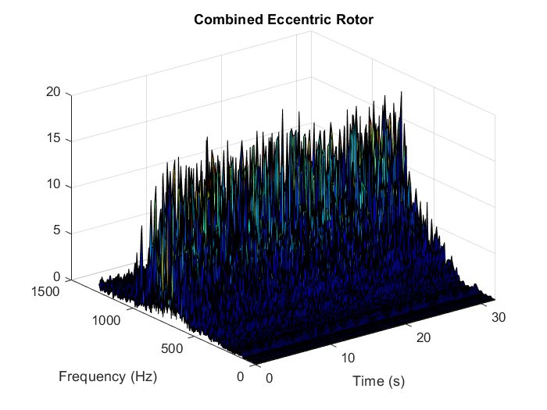

**Figure 25: STFT plot of 'Cocked Rotor Fault’, 3D (upper part), 2D (lower part)**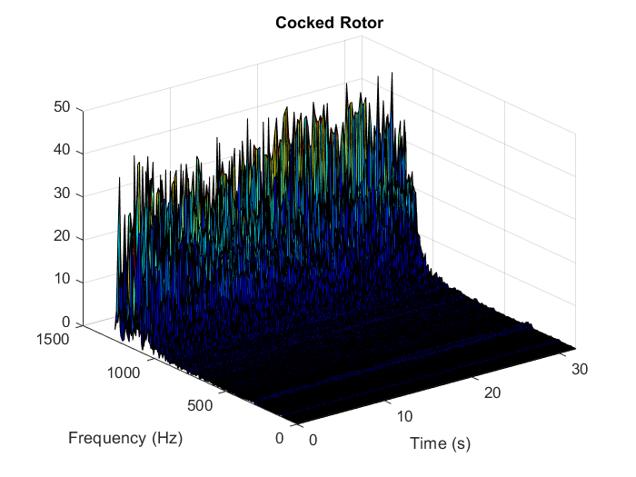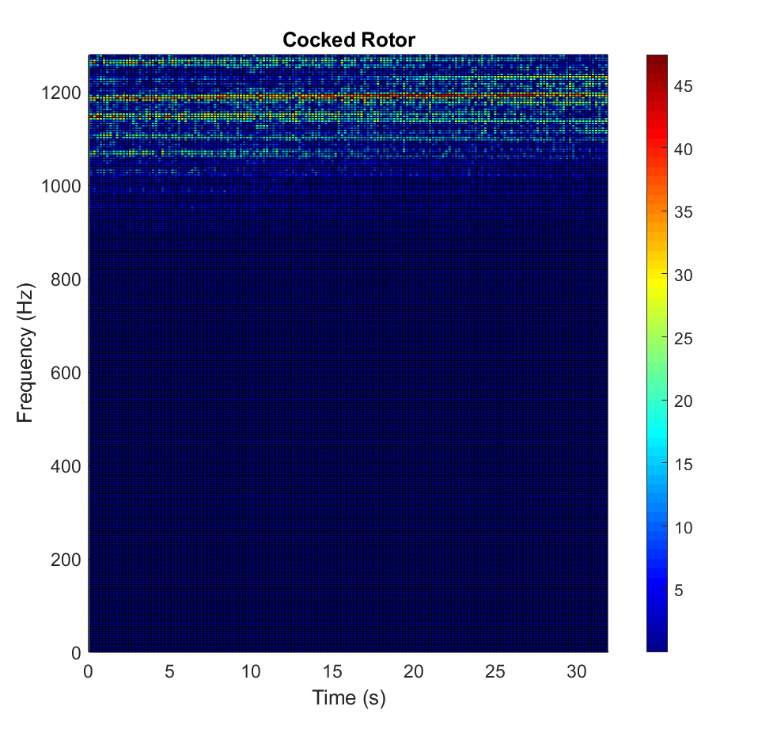

Figure 27: STFT plot of 'Cocked Rotor Fault’, 3D (upper part), 2D (lower part)

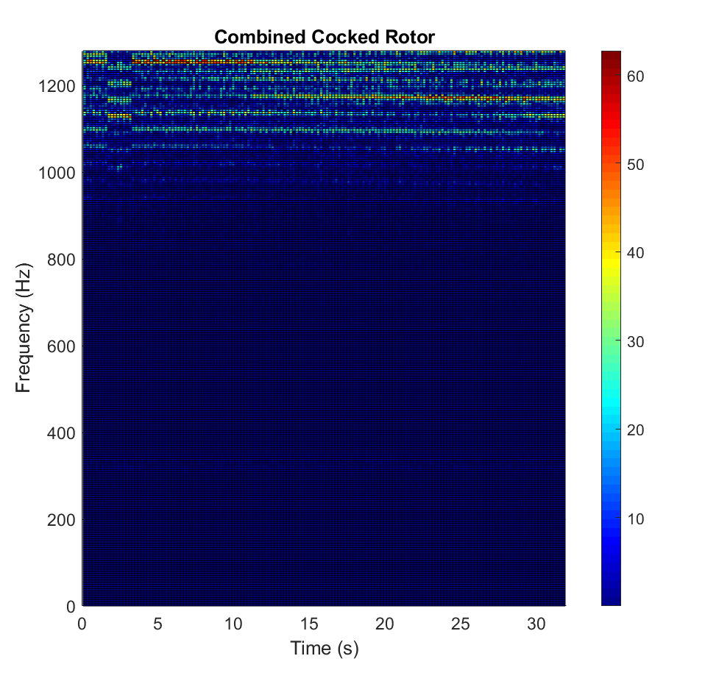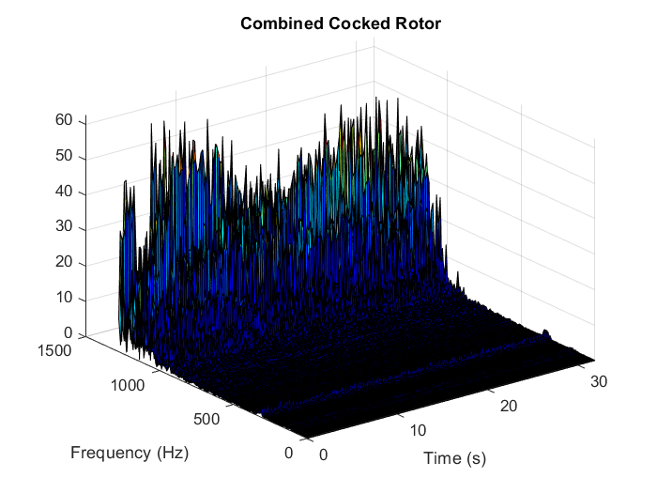

**Figure 26: STFT plot of 'Combined Cocked Rotor Fault’, 3D (upper), 2D (lower)**

**Figure 27: STFT plot of 'BIRF', 3D (upper part), 2D (lower part)**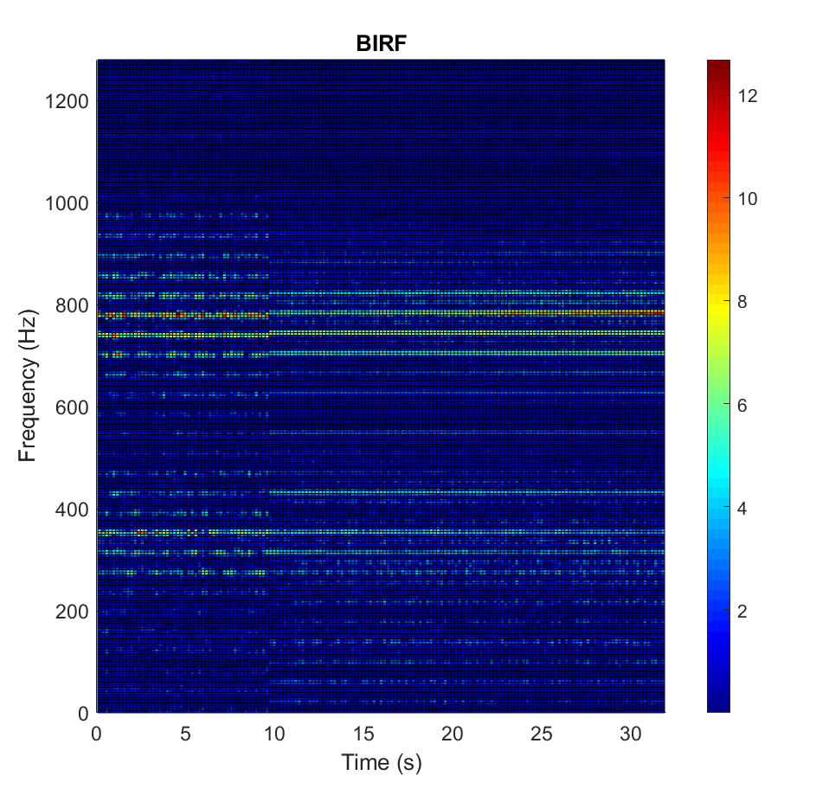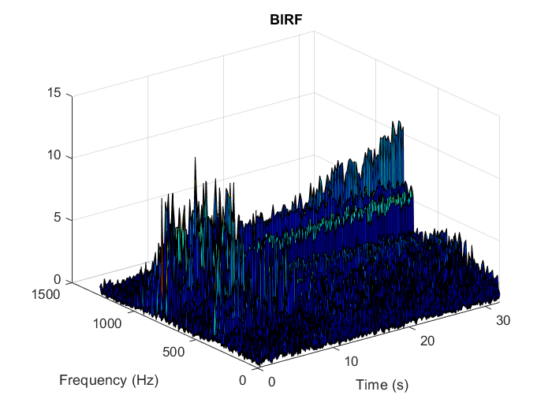

**Figure 28: STFT plot of 'Combined BIRF’, 3D (upper part), 2D (lower part)**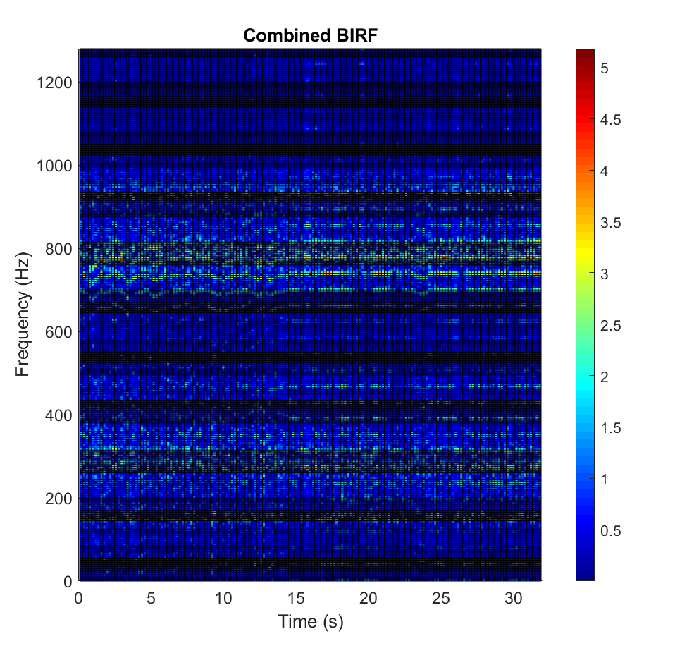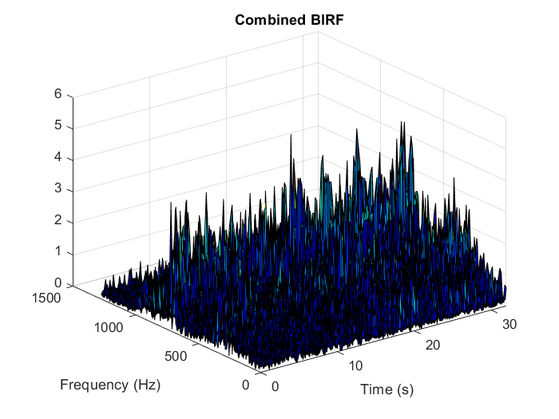

**Figure 29: STFT plot of 'BORF’, 3D (upper part), 2D (lower part)**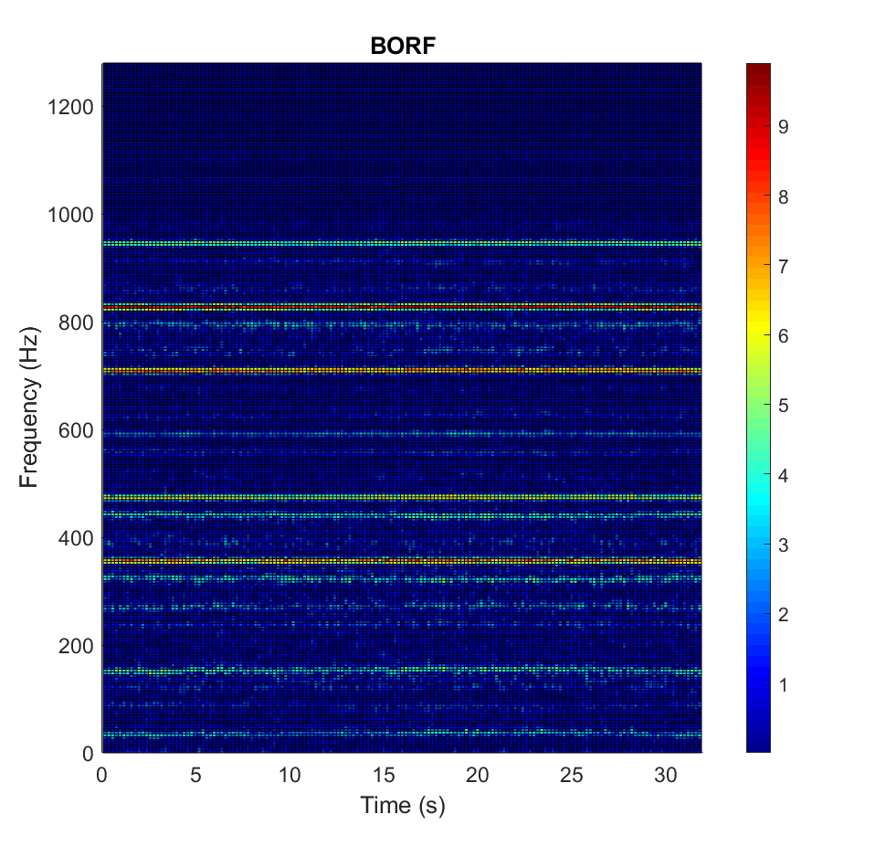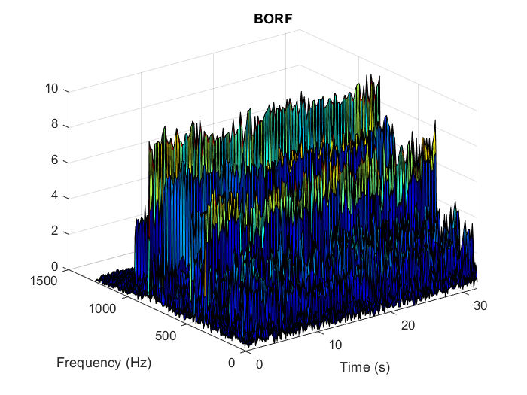

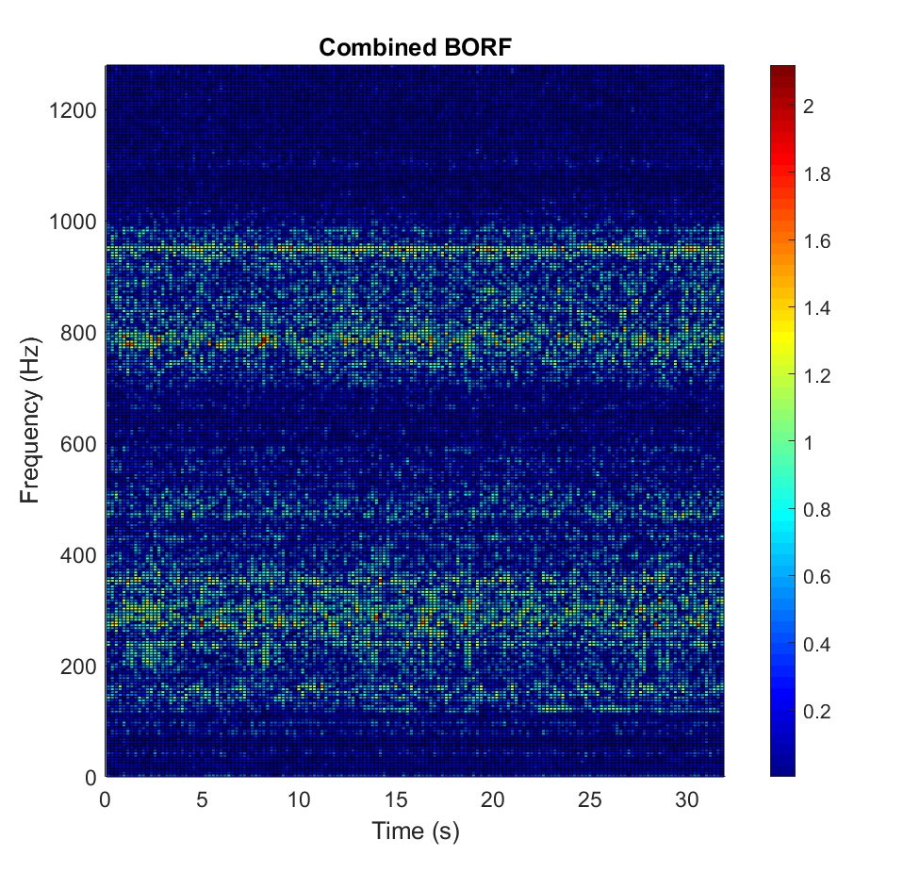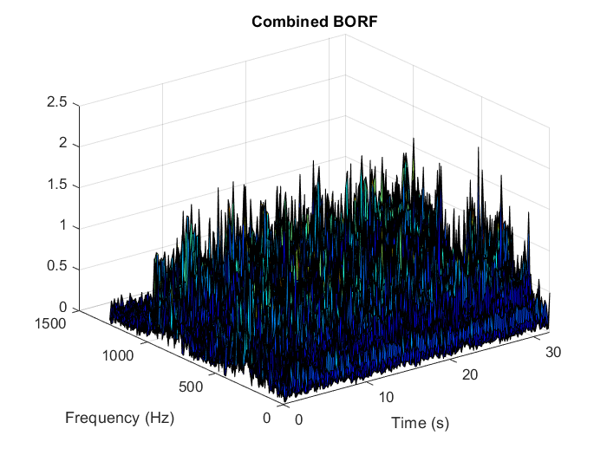

**Figure 30: STFT plot of 'Combined BORF’, 3D (upper part), 2D (lower part)**

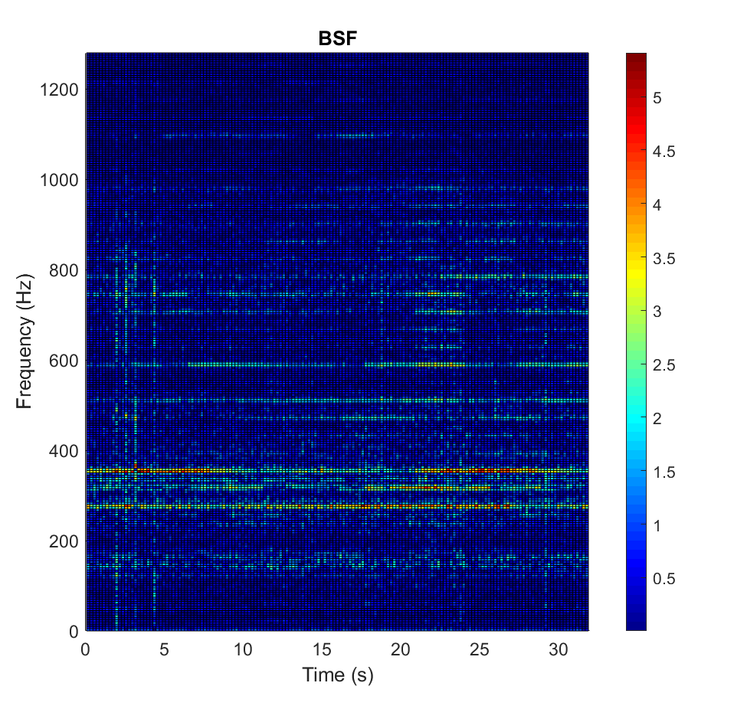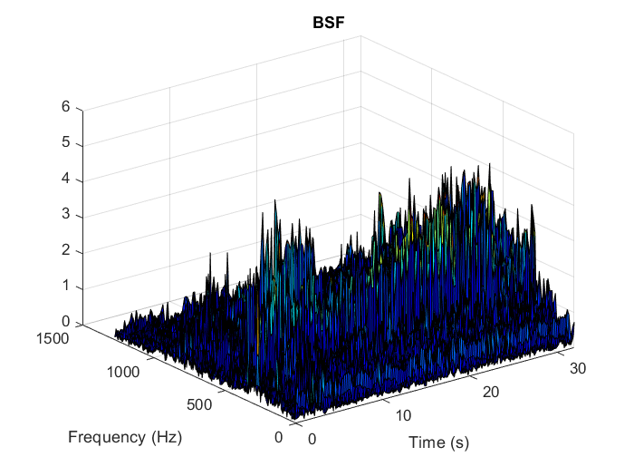

**Figure 31: STFT plot of 'BSF’, 3D (upper part), 2D (lower part)**

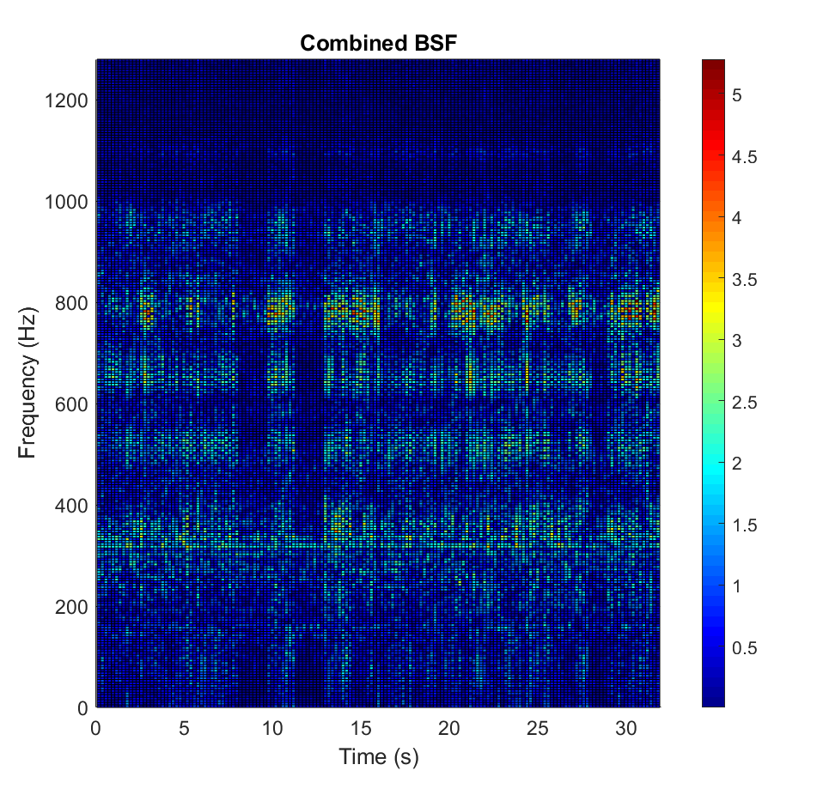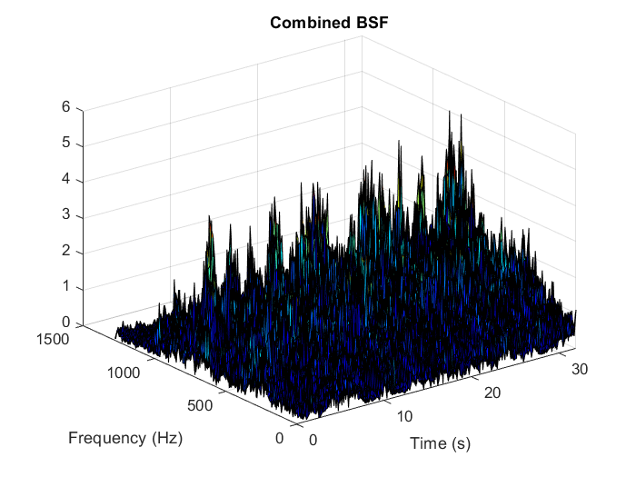

**Figure 32: STFT plot of 'Combined BSF ’, 3D (upper part), 2D (lower part)**

### STFT Observations

1. **STFT of missing tooth fault**

From STFT plot, it can be seen that first dominant is at 40 Hz, which is the operating frequency of the system. Subsequent peaks can be found at multiples of 40 Hz. The highest peak can be seen at 360 Hz. Most of the dominant peaks lie below 800 Hz. Near 800 Hz there is a distortion in the distribution of peaks.

1. **STFT of loose gear fault**

It can be seen that both distinct and combined loose gear faults have a similar distribution to that of missing tooth fault. Peaks in STFT plot of distinct fault are sharper compared with peaks in STFT plot of combined fault. The highest peak can be seen at 360 Hz.

1. **STFT of unbalance fault**

In STFT plots of distinct and combined unbalance fault, dominant peaks can be seen at an interval of 40 Hz. In case of distinct fault peaks are visible beyond 800 Hz, while in case of a combined fault, peaks are visible from 1000 Hz.

1. **STFT of eccentric rotor** **fault**

In STFT plots of distinct and combined eccentric rotor fault, dominant peaks can be seen at an interval of 40 Hz. For distinct fault, peaks are visible in a range of 400-600 Hz, while for combined fault, peaks are visible in a range of 600-900 Hz.

1. **STFT of cocked rotor fault**

It can be seen that in STFT plots of distinct and combined cocked rotor fault, all major peaks lie beyond frequency 1000 Hz. Also, peaks are visible in an interval of 40 Hz.

1. **STFT of bearing inner race fault**

In the case of distinct BIRF, dominant peaks can be visible in a higher range of 680-800 Hz and in the lower range of 280-440 Hz range. Peaks occur at a frequency interval of 40 Hz. Similar distribution can be seen in combined BIRF. In distinct BIRF, peaks are concentrated in the small frequency range, while in case of a combined fault, STFT distribution is distorted due combination of faults.

1. **STFT of bearing outer race fault**

First dominant peak in STFT of distinct BORF is at 40 Hz. There are also sharp peaks at multiples of 120 Hz, which is a fundamental defect frequency of BORF. Peaks are visible at 360 Hz, 480 Hz, 720 Hz, 840 Hz, 960 Hz. In the case of combined BORF, overall distribution is the same as of distinct BORF, but peaks are distributed in the large frequency range.

1. **STFT of ball spin fault**

In STFT plot of distinct BSF, three dominant peaks are visible at an interval of 40 Hz, which are at 280 Hz, 320 Hz, 360 Hz. While in STFT plot of combined BORF, peaks are distributed in the large frequency range.

### Analysis

For any sampling interval $∆$, there exists a frequency, called Nyquist Critical Frequency, given by,

|  |  |  |
| --- | --- | --- |
|  | $$f_{c}=\frac{1}{2∆}$$ | **6.1** |

If any function $h(t)$ happens to be bandwidth limited to frequencies smaller than $f_{c}$, then function $h(t)$ can be entirely determined by sampled data [32]. But if it has some frequencies higher than $f_{c}$, then sampled data is not enough to represent function $h(t)$. In the present problem, the sampling frequency is 2560 samples/sec. By the above relation, Nyquist Critical Frequency is half of the sampling frequency, which is 1280 Hz. Possible conclusions & analysis of combined fault’s classification results along with their STFT plots is done below.

1. **Combined Fault of Missing Tooth & Loose Gear**

Both the components of this fault are diagnosed by respective networks successfully. After comparing STFT plots of distinct Loose Gear fault and combined Loose Gear fault, we can see that both plots have similar distribution along the frequency axis. Dominant frequencies are multiples of 40 Hz, which is operating frequency of machine fault simulator. Also, almost all of the significant frequencies are smaller than 800 Hz, which is far less than critical frequency. This might be the reason for the successful detection of the fault.

1. **Combined Fault of Missing tooth & Unbalance**

Only one component of this fault, ‘Missing Tooth’ is detected successfully. If we look at the STFT plot of its other component, ‘Unbalance’, most of the significant frequencies lies in the region above 1000 Hz and frequencies above 1280 Hz couldn’t be captured by data. These frequencies may be important for fault detection.

1. **Combined Fault of Missing Tooth & Eccentric Rotor**

Most of the significant frequencies are lies in the region of 500 Hz to 900 Hz, which are smaller than critical frequncy1280 Hz. Networks successfully detect both the components of these faults.

1. **Combined Fault of Missing Tooth & Cocked Rotor**

Similar to ‘Unbalance’ Fault, many significant frequencies of cocked rotor lie in spectrum near the critical frequency. In this fault also, only ‘Missing Tooth’ component is detected while the ‘Cocked rotor’ component remains undetected.

1. **Combined Faults of Missing Tooth & Bearing Defects**

In STFT plots of faults of BIRF, BSF, BORF, we can see sharp peaks near those frequencies which are multiples of operating frequencies. In contrary to that, in their respective counterpart of combined faults, there is a distortion in the distribution of STFT. Instead of 2-3 sharp peaks near dominant frequency, we can see many smaller peaks distributed in a large spectrum. Due to this reason, the second component of bearing defect might not be detected correctly by networks. This problem may be solved by the higher sampling frequency, provided that higher frequencies won’t be distorted due to combination with another fault.

## CONCLUSION

For Multi-label fault identification of a rotor system, problem transformation method is adopted, and Multi-label classification problem is converted into a number of binary classification problems. Thus eleven different networks have been developed in this study. Raw time-domain sensor response is used without any pre-processing for constructing an input layer. All of these networks are trained by using only distinct fault data. Combined fault data is not used for training as well as for validation purpose and thus building a robust model is attempted. Considerably fewer amounts of data requirement & lower computational power requirement compared with label power set method makes this approach attractive and practical for a large number of target classes.

In this study, seven combined faults are tested to evaluate the performance of all classifiers. These seven faults are composed of two distinct faults components, in which one of the components, ‘Missing Tooth’, is common for all of the seven and other component is different for every fault. As a result, the ‘Missing Tooth’ fault component is successfully identified in almost all of the examples of combined faults. In two out of the seven faults, another fault component is also detected. While in case of other combined faults, networks remained unsuccessful in identifying another fault component.

Above limitations may be addressed by adopting a higher sampling rate of data collection and collecting more number of examples of each fault to overcome the problem of overfitting. Also, Attempt should be made in future studies, to understand the phenomenon of distortion in the distribution of STFT plot of combined fault due composition of two or more faults.

# Bibliography

VYAS. (2001). rOTOR mODELLING. *MREXDG*, 451.

# Bibliography

VYAS. (2001). rOTOR mODELLING. *MREXDG*, 451.

REFERENCES

[1] A.R. Mohanty, “NPTEL : Mechanical Engineering - Machinery fault diagnosis and signal processing.” https://nptel.ac.in/courses/112/105/112105048/ (accessed Jun. 12, 2020).

[2] D. Satishkumar, “Artificial Neural Networks For Fault Diagnosis Of Rotating Machinery,” IIT Kanpur, 1997.

[3] J .Singh, “Condition Monitoring of Geared Rotor Systems using Neaural Networks,” IIT Kanpur, 2006.

[4] S. Fatima, B. Guduri, A. R. Mohanty, and V. N. A. Naikan, “Transducer invariant multi-class fault classification in a rotor-bearing system using support vector machines,” *Meas. J. Int. Meas. Confed.*, vol. 58, pp. 363–374, 2014, doi: 10.1016/j.measurement.2014.08.042.

[5] O. Janssens *et al.*, “Thermal image based fault diagnosis for rotating machinery,” *Infrared Phys. Technol.*, vol. 73, pp. 78–87, 2015, doi: 10.1016/j.infrared.2015.09.004.

[6] O. Janssens, R. Van De Walle, M. Loccufier, and S. Van Hoecke, “Deep Learning for Infrared Thermal Image Based Machine Health Monitoring,” *IEEE/ASME Trans. Mechatronics*, vol. 23, no. 1, pp. 151–159, 2018, doi: 10.1109/TMECH.2017.2722479.

[7] H. Jeong, S. Park, S. Woo, and S. Lee, “Rotating Machinery Diagnostics Using Deep Learning on Orbit Plot Images,” *Procedia Manuf.*, vol. 5, pp. 1107–1118, 2016, doi: 10.1016/j.promfg.2016.08.083.

[8] H. Oh, B. C. Jeon, J. H. Jung, and B. D. Youn, “Smart diagnosis of journal bearing rotor systems: Unsupervised feature extraction scheme by deep learning,” *Proc. Annu. Conf. Progn. Heal. Manag. Soc. PHM*, vol. 2016-Octob, pp. 109–116, 2016.

[9] G. Georgoulas *et al.*, “The use of a multilabel classification framework for the detection of broken bars and mixed eccentricity faults based on the start-up transient,” *IEEE Trans. Ind. Informatics*, vol. 13, no. 2, pp. 625–634, 2017, doi10.1109/TII.2016.2637169.

[10] M. Sadoughi, A. Downey, G. Bunge, A. Ranawat, C. Hu, and S. Laflamme, “A deep learning-based approach for fault diagnosis of roller element bearings,” *Proc. Annu. Conf. Progn. Heal. Manag. Soc. PHM*, 2018, pp. 1-7doi:10.1234/phmconf.2018.v10i1.526.

[11] Z. Yuan, L. Zhang, and L. Duan, “A novel fusion diagnosis method for rotor system fault based on deep learning and multi-sourced heterogeneous monitoring data,” *Meas. Sci. Technol.*, vol. 29, no. 11, 2018, doi: 10.1088/1361-6501/aadfb3.

[12] R. Liu, B. Yang, E. Zio, and X. Chen, “Artificial intelligence for fault diagnosis of rotating machinery: A review,” *Mech. Syst. Signal Process.*, vol. 108, pp. 33–47, 2018, doi: 10.1016/j.ymssp.2018.02.016.

[13] X. Zhu *et al.*, “Rotor fault diagnosis using a convolutional neural network with symmetrized dot pattern images,” *Meas. J. Int. Meas. Confed.*, vol. 138, pp. 526–535, 2019, doi: 10.1016/j.measurement.2019.02.022.

[14] S. Ma and F. Chu, “Ensemble deep learning-based fault diagnosis of rotor bearing systems,” *Comput. Ind.*, vol. 105, pp. 143–152, Feb. 2019, doi: 10.1016/j.compind.2018.12.012.

[15] Z. Shi and W. Dong, “Analysis of Turbine Rotor Fault Diagnosis Method,” *IOP Conf. Ser. Mater. Sci. Eng.*, vol. 686, no. 1, 2019, doi: 10.1088/1757-899X/686/1/012025.

[16] Z. Xiaoxun, Z. Jianhong, H. Dongnan, and H. Zhonghe, “Research on mechanical rotor condition monitoring based on VCNN,” in *Energy Procedia*, Feb. 2019, vol. 158, pp. 6393–6398, doi: 10.1016/j.egypro.2019.01.208.

[17] F. Ben Abid, M. Sallem, and A. Braham, “Robust Interpretable Deep Learning for Intelligent Fault Diagnosis of Induction Motors,” *IEEE Trans. Instrum. Meas.*, vol. 69, no. 6, pp. 3506–3515, 2019, doi: 10.1109/tim.2019.2932162.

[18] N. Sonkul, “Deep Learning Protocol for Condition Monitoring and Fault Identification in a Rotor-Bearing System from raw Time-Domain data,” 2019.

[19] H. Wang, S. Li, L. Song, and L. Cui, “A novel convolutional neural network based fault recognition method via image fusion of multi-vibration-signals,” *Comput. Ind.*, vol. 105, pp. 182–190, 2019, doi: 10.1016/j.compind.2018.12.013.

[20] P. Chattopadhyay, N. Saha, C. Delpha, and J. Sil, “Deep Learning in Fault Diagnosis of Induction Motor Drives,” *Proc. - 2018 Progn. Syst. Heal. Manag. Conf. PHM-Chongqing 2018*, pp. 1068–1073, 2019, doi: 10.1109/PHM-Chongqing.2018.00189.

[21] A. Nandi, S. Biswas, K. Samanta, S. S. Roy, and S. Chatterjee, “Diagnosis of Induction Motor Faults Using Frequency Occurrence Image Plots - A Deep Learning Approach,” *Proc. - 2019 Int. Conf. Electr. Electron. Comput. Eng. UPCON 2019*, pp. 1–4, 2019, doi: 10.1109/UPCON47278.2019.8980279.

[22] S. Kumar *et al.*, “A Comprehensive Review of Condition Based Prognostic Maintenance (CBPM) for Induction Motor,” *IEEE Access*, vol. 7, pp. 90690–90704, 2019, doi: 10.1109/ACCESS.2019.2926527.

[23] W. J. Lee, K. Xia, N. L. Denton, B. Ribeiro, and J. W. Sutherland, “Development of a speed invariant deep learning model with application to condition monitoring of rotating machinery,” *J. Intell. Manuf.*, no. Kim 2019, 2020, doi: 10.1007/s10845-020-01578-x.

[24] D. S. Alves *et al.*, “Uncertainty quantification in deep convolutional neural network diagnostics of journal bearings with ovalization fault,” *Mech. Mach. Theory*, vol. 149, p. 103835, 2020, doi: 10.1016/j.mechmachtheory.2020.103835.

[25] W. J. Lee, H. Wu, A. Huang, and J. W. Sutherland, “Learning via acceleration spectrograms of a DC motor system with application to condition monitoring,” *Int. J. Adv. Manuf. Technol.*, vol. 106, no. 3–4, pp. 803–816, 2020, doi: 10.1007/s00170-019-04563-8.

[26] T. Mitchell, “*Machine Learning*”, vol. 17. 1997.

[27] I. Goodfellow, Y. Bengio, and A. Courville, “*Deep learning*”,2016.

[28] R. S. Nitish Srivastava, Geoffrey Hinton, Alex Krizhevsky, Ilya Sutskever, “Dropout: A Simple Way to Prevent Neural Networks from Overfitting.” http://jmlr.org/papers/v15/srivastava14a.html (accessed Jun. 12, 2020).

[29] J. Read, B. Pfahringer, G. Holmes, and E. Frank, “Classifier chains for multilabel classification,” *Mach. Learn.*, vol. 85, no. 3, pp. 333–359, 2011, doi: 10.1007/s10994-011-5256-5.

[30] H. Saruhan, S. Saridemir, A. Çiçek, and I. Uygur, “Vibration analysis of rolling element bearings defects,” *J. Appl. Res. Technol.*, vol. 12, no. 3, pp. 384–395, 2014, doi: 10.1016/S1665-6423(14)71620-7.

[31] A. Mertins, “*Signal analysis: wavelets, filter banks, time-frequency transforms and applications*”, 1999.

[32] W. H. Press, S. A. Teukolsky, W. T. Vetterling, B. P. Flannery , “ *Numerical recipes : the art of scientific computing*”, 2007 .